**A Primer on the Time Value of Money**

**&**

**Mathematics of Real Estate Finance**

By: James R. DeLisle, Ph.D.

Revised: Fall, 2008

Table of Contents

Preface iii

What is this Topic Doing in my Curriculum? iii

Introduction to TVM 1

The Money-Time Nature of Real Estate 1

Graphical Depiction/Visualization 1

Total Nominal Cost vs. Present Value Cost 2

Present Value Imperative 3

Simple Interest vs. Compound Interest 4

Mathematical Empowerment 6

Analytical Intuition 6

Organization 7

Overview of 6 Functions of $ 8

Basic TVM Terminology 8

Alternative Methodologies for TVM Analysis 10

Graphical Representation of 6 Functions of $ 10

Detailed Review of 6 Functions of $1 13

FV1: Future Value of Lump 13

FVA: Future Value of Annuity 16

SF: Sinking Fund 20

PV1: Present Value of Lump 24

PVA: Present Value of Annuity 27

PR: Periodic Repayment to Amortize $1 30

Conclusion 32

# Preface

## What is this Topic Doing in my Curriculum?

Or, Why Should I Bother?

The typical real estate student may feel they are above the level of basic “Time Value of Money (TVM),” having magically catapulted to the world of canned spreadsheet applications or commercial discounted cash flow packages. While such tools are readily available, they cannot be validly and reliably applied without a firm understanding of the underlying mathematics of real estate finance. This caveat is based on the fact that despite the significant progress that has been made in standardizing real estate terminology and contracts as a byproduct of the emergence of the public market, that in reality, real estate remains largely an inefficient, private market in which transactions are negotiated on an individual basis. Furthermore, there are a wide variety of economic elements of real estate transactions that create an overwhelming array of combinations and permutations which can materially affect the economic viability of a particular investment. While spreadsheets and canned models can go a long way toward taking the tedium out of running a seemingly infinite array of numbers, such an approach is both inefficient and ultimately ineffective in arriving at an optimal solution.

While the previous discussion might suggest that real estate financial calculations are inherently complex, the reality is that an analyst who understands the nuances of TVM can arrive at optimal decisions in an efficient manner. Furthermore, no matter who you are or what background or training you have, you can become an analyst; at least to the extent that you can master the skills necessary to model the investment performance of real estate opportunities, both residential and commercial, both individual and portfolio. As you will soon learn, an understanding of basic TVM can help you win in real estate negotiations, since the literate party can quickly and intuitively understand the nature and bottom line impact of tradeoffs that may be placed on the table during negotiations. Furthermore, you can develop an understanding for the sensitivity of returns to changes in basic assumptions, either in a particular investment profile, or in the broader economic and investment market in which such decisions are being made.

Whether you become a professional whose bread and butter depends on real estate, an investor who dabbles in real estate, or a user who buys or leases property, you will find the insights and skills conveyed in this book to be invaluable assets. This claim is especially true when juxtaposed against the alternative of blindly plugging in assumptions, hoping that they will produce the desired return or project valuation. While it might seem that mathematical calculations may be trivial and the answers obvious, the reality is that the underlying elements can take a number of gyrations that make the quantification of dependent variables extremely complicated and time consuming. You might be tempted to think that you can avoid the tedium of beginning with the basics and crunching numbers on a calculator in favor of some canned computers packages. If you go down this path, however, you will quickly find that such trial and error approaches are not efficient. Furthermore, they will not provide you with the ability to assess the financial risks associated with a real estate opportunity since you will not have an adequate analytical foundation upon which to model such issues. Thus, if you allow yourself to remain a naïve user blindly plugging in numbers, you will likely never develop an understanding of their interactive effects and the unanticipated linkages among them. Rather, you will be left with a confusing array of outputs that cloud the underlying economics of an investment or, even more limiting, give you a false sense of security that you have arrived at the ultimate answer. Then, when things change, as they inevitably will, you will be forced to start the random process over again, relying on luck to carry you through the uncertain future.

# Introduction to TVM

## The Money-Time Nature of Real Estate

By its very nature, real estate is a capital-intensive asset that has both space-time and money-time dimensions. That is, the underlying asset includes a number of spatial elements (e.g., site, building, neighborhood, linkages) that characterize it at a certain point in time, for a certain time period. At the same time, the money-time element refers to the fact that real estate rights are typically vested for a specific period of time in return for some income or personal use/enjoyment that compensates the capital that either acquired or developed the underlying asset. The duration of these temporal elements is related to the type of control that a party exerts over the real estate, ranging from a perpetual interest that can be assigned to heirs, to a lease that creates a tenant interest for a specified term subject to the payment of a certain amount of rent. Once the magnitude and timing of cash flows can be delineated and return requirements or interest rates specified, TVM calculations can be used to determine the “value” of the transaction. Since money has a temporal dimension (e.g., $100 today is worth more than $100 in 5 years), and decision-makers are usually comparing alternative deals, Present Value (PV) is typically used to bring everything back to the current time and ensure that alternatives are compared on an “apples-to-apples” basis.

## Graphical Depiction/Visualization

Given the various combinations and permutations of cash flows surrounding real estate transactions, and the number of independent items that can affect investments, one of the challenges analysts face is the ability to visualize the actual pattern of revenues and receipts. Without this intuitive understanding, it is difficult to set up problems so that they can be solved in an efficient manner. Fortunately, once the basic elements of TVM are mastered, one can easily extract the “direction” of changes in a dependent variable (e.g., rate of return, value).

**Exhibit 1: The Money/Time Continuum**

+

Money

Time

-

T = 5

T = 0

Illustration 1 lays out a basic graphical representation of the money/time relationship. As noted, time is represented on the horizontal or x-axis; money is represented on the vertical or y-axis. The Money axis extends from the negative to the positive, with the intersection of the Time axis establishing the “0” point. The Time axis spans from the past to the future, with the intersection of the Money axis delineating the “current time” which is also often noted T=0. The future is generally counted in terms of the number of periods from today; with T=5 suggesting that it is 5 years hence.

While we want to keep this initial discussion simple, it should be noted that there are two additional temporal elements that will be key in TVM calculations: periodicity, and beginning/end of period.

* Periodicity. The notion of “periodicity” refers to the number of compounding periods per year. For example, a periodicity of 1 would indicate annual payments. On the other hand, a periodicity of 12 would indicate monthly payments (i.e., 12/’year).
* Beginning/End of Period. The beginning/end of period notion comes into play since there can be significant differences in the value/cost of some exchange of capital depending on whether it occurs at the beginning of the period (BOP) or the end of the period (EOP). This is especially true if there is differing from the initial exchange. For example if you receive $1,000 at the beginning of the first year, and pay back the future value at the end of the 5th year, you have really held onto the capital for 6 years, not 5 years.
* Consistency. In both periodicity and BOP/EOP calculations, the key is to keep the base consistent to support apples-to-apples comparisons. For example, if you receive 7% interest, compounded annually, for a 5 year hold you would enjoy 5 steps or earning periods in your principal plus interest calculations. On the other hand, if you received 7% annual, compounded monthly, you would enjoy 60 steps or earning periods (i.e., 5 * 12). On a similar note, the calculation of holding period costs/benefits should be consistent, with both inflows and outflows expressed in BOP or EOP bases; they should not be inconsistent or the number of compounding principles should be adjusted.

## Total Nominal Cost vs. Present Value Cost

The fallacies of using nominal dollars can be illustrated with a couple of examples. Take the case of the purchase of a house that you buy for $240,000 and get a 7.5%, 30 year, fixed rate mortgage with monthly payments. On a simple level, you might think you are paying $14,440 in interest (i.e., $240,000 * 80% loan to value * 7.5% interest). In reality, you will be making monthly payments of $1,341 for 360 months. If you own the house for the full term, you will be making total payments of $483,297. If you subtract the initial loan amount, that is $291,297 in interest alone. If interest rates were 10%, the total payments would balloon to $606,577, with a monthly payment of $1,685, more than $344 above the 7.5% rate. This elasticity of payments, especially compared to wages which are less volatile –at least on the upside-- is one reason that homeowners can get caught with low teaser rate financing on variable rate loans. Once the loan resets, the jump in payments to the initial rates can be onerous. This situation can be further complicated if rates rise as can be expected as the cycle unfolds, their ability to pay may not keep up with interest rates.

Another example can be drawn from a recent effort to defeat a monorail project in Seattle. After being narrowly approved on two occasions, when another opportunity came up to force a vote, opponents used total nominal dollars costs to exaggerate the effective cost of the project on voters. When the aggregate dollars were added up, the apparent cost was daunting, helping tip the polls toward an eventual defeat. Given the state of infrastructure and the need for deferred maintenance, it is likely such tactics will continue to be used to defeat future measures. Unfortunately, since many voters and members of the general public do not understand TVM, the risk of making sub-optimal decisions on poor economics remains. Fortunately, those of you who work your way through this material should be in a position to: 1) analyze the true costs of various scenarios yourselves, 2) help educate others on the impact of TVM on decisions, and 3) develop more creative, cost-effective financial structures to achieve certain goals and objectives.

## Present Value Imperative

One might question why so much emphasis is placed on Present Value; isn’t it true that dollars are dollars? While dollars are indeed relatively fungible (i.e., a dollar is a dollar is a dollar, either paper, silver or some equivalent), the value or purchasing power of a dollar varies dramatically over time. Since real estate and other investment decisions have a temporal nature (i.e., they occur or endure for some finite period), to make a correct economic or financial decision, it is critical that future outflows or inflows be expressed in present dollars. This is especially true since options often have different time periods and different risks. The only way to compensate for these differences and inherent uncertainty, is to bring the economics to a common point in time. Typically, future dollars are brought to the current or present time, although a fixed future time would be just as valid. The key in such decisions is to state the economics of various options on an “apples to apples” basis. While non-economic factors are also typically incorporated in decision making, having the economic elements expressed in clear and unambiguous terms helps the decision maker focus on other elements or criteria.

## Simple Interest vs. Compound Interest

Before getting into any detailed TVM discussion, it is important to explore the differences by compound vs. simple interest since compounding is built into all TVM calculations. Consider the following example to see the differences.

**1 (a): Simple Interest**

Using simple interest, our $1,000 would earn $75/period for 5 periods. Thus, the math is relatively straightforward. Namely,

Total interest = ($1,000 * 7.5%*5yr)

= $375

Future Value = PV + Total interest

= $1,000 + $375

= $1,375

**Exhibit 2: Simple Interest**



**1 (b): Compound Interest**

In the case of compound interest, we would earn interest on the interest, compounding forward to a future lump sum. Thus, the math is a little more complicated since it introduces an exponential function. Namely,

**Table 1 (a): Exponential Equation for Compounding FV**



Note that we are keeping this example simple by looking only at annual payments so the Term (t) is the same as the number of compounding periods. In the future, we will denoted the Term as t, but the compounding periods/year will be denoted as “m.” Thus, if this example was monthly, the Compounding Periods would be 60 (i.e., 5 * 12)

**Table 1 (b): Tabular Example of Compounding PV**



As noted in Illustration 3 (b), the first $75 is added to the initial amount at the End of the period, and then earns interest at the 7.5% rate which compounds forward to $80.63. Thus, the $5.63 is the interest on the interest. That becomes the End of the period balance, and is compounded forward with the process continuing until the end of the term.

## Mathematical Empowerment

Some of you may be wondering whether it is worth it to waste time playing with numbers and graphs, contending that real estate is essentially a people business in which the art of the deal dominates who does what. While the behavioral element is indeed important, the capital-intensive nature of real estate and its long-term nature quickly rise to the top of the chain in importance. Indeed, there are countless examples of real estate investors who have lost their properties and their personal wealth by underestimating the importance of solid financial analysis. On the other hand, those who have been able to amass and sustain wealth accumulation over the full real estate cycle have all learned how to manage finances for individual projects, as well as for real estate portfolios.

## Analytical Intuition

In many respects, you have undoubtedly found out that life is a matter of timing and luck; being in the right place at the right time. This axiom carries over to real estate, although with one major caveat. Namely, one has to be able to identify a great deal and be mobilized to strike when the iron is hot. While this might seem obvious, during periods when the market is extremely active and capital is chasing deals, one can easily be confused by the various machinations and financial engineering used to make projects pencil out. Examples of such practices include: bullet-loan financing (e.g., 30 year amortization, 3 year due clause); use of subordinated or mezzanine financing at higher rates to attract more equity; participating and convertible loans to increase yields over face rates; negative amortization loans which actually grow rather than shrink in terms of outstanding balances; and, use of rent spikes in proforma cash flows to increase paper returns over hurdle rates. In addition, by incorporating more advanced techniques such as sensitivity analysis and Monte Carlo simulation, which we will introduce later, one can model the vulnerability of individual assets to various market risks and economic scenarios. Finally, when individual investments are rolled up into a “portfolio,” one can manage such risks by applying portfolio management techniques including diversification and asset allocation. Unfortunately, TVM analysis cannot avoid all such risk exposures, especially those caused by unpredictable shocks to the system. However, it can go a long way to avoiding situations that are “accidents waiting to happen.”

The intellectual and mathematical range of analytical skills alluded to in the previous discussion might be daunting to a novice or one with a passing interest in real estate investing. The good news is that even the most sophisticated forms of real estate analysis can be reduced to a manageable number of TVM steps. Thus, while analyzing the previous types of problems is beyond the scope of this guide, mastering the concepts herein is a necessary condition to be able to analyze more complex problems. Without such an understanding, it would be impossible to make fundamentally sound decisions, to independently analyze the true cost of various options, select the “best option” for yourself when looking at alternatives, or evaluate the quality of financial advice you get from others. As you will note in this guide, such fundamentals are relatively straightforward in terms of using based Future Value (FV) and Present Value (PV) concepts. By building on this foundation, you will be able to convert future cash flows of various investment or acquisition option with different magnitudes, patterns and risks to a common denominator. This denominator can be their true Present Value, or the time-adjusted rate of return they promise if the assumptions you make are borne out. This latter form of analysis is especially important in real estate, with its long-term, capital-intensive nature. Indeed, when purchasing real estate, you are really buying a set of assumptions rather than mere bricks and mortar. As such, by being able to master basic TVM math and model alternatives, you can explore options quickly and efficiently. This ability will allow you to turn your attention to more important issues such as whether the assumptions you make in your modeling are valid and reasonable. Further, you will be able to apply sensitivity analysis to determine how stable your conclusions are relative to the various assumptions or possible changes in market conditions (e.g., increasing interest rates, slowing appreciation in housing markets) you make in your analysis. The importance of being able to conduct such analysis can be punctuated by the plight of the legions of recent homebuyers who purchased at the end of the boom cycle and turned to structured financing, as well as those who converted fixed-rate loans to adjustable rate loans to tap into home equity and lower payments at the same time.

As you will note in this guide, TVM can help you convert real estate alternatives with a myriad of confusing and seemingly unrelated options from apples to oranges, to apples to apples. As such, you will be able to make an objective decision can be made on the merits of the deals rather than on a confusing set of numbers that have little meaning. You will also note that by mastering these basics and by cultivating the ability to visualize cash flows and reduce complex problems into simple, discrete components, you will be prepared to approach a range of heretofore complicated decisions from a solid analytical perspective. Ultimately, by applying various decisions models, you will be able to combine the quantitative elements of a problem with the qualitative elements, allowing you to make logical choices that have a high probability of satisfying explicit goals and objectives that you establish.

## Organization

We have designed this workbook for you, regardless of whom you are and where you come from. Our intent is to provide you with a solid, incremental approach to the mathematics of real estate finance and investment analysis. We start with the basics, and then build up to more sophisticated concepts. To address the needs of those of you who will likely return to this material for a refresher at some point in time, or to fill in some gap in understanding some of the more subtle nuances of TVM, we have also taken care to ensure that the materials are cross-referenced and draw on the same jargon, acronyms and equations. Since learning TVM is by necessity a participatory sport, we have also compiled a number of examples that can be used as practice exercises. If you get stuck, you can refer back to the building blocks and/or visualization processes that can help fill in the missing pieces of your analysis. Welcome to the wonderful world of real estate finance!

# Overview of 6 Functions of $

## Basic TVM Terminology

Illustration 4 provides an overview of the 6 Functions of $. As depicted, 3 functions deal with Present Value, and 3 functions deal with Future Value. The acronyms and corresponding definitions include:

* **Present Value**. The current value of future receipts or payments.
  + **PV1**. The present value of a future lump sum (i.e., single payment) received at some finite time period assuming a stated discount rate.
  + **PVA**. The present value of a series of equal, fixed interval payments, received over some finite time period assuming a stated discount rate. This is also referred to at the PV1/P.
  + **SF**. The series of equal, fixed interval payments received over some finite time period necessary to grow to a targeted future amount earning a stated rate.
* **Future Value**. The value of current or prior receipts or payments in the future.
  + **FV1**. The future value a present lump sum (i.e., single payment) received today will compound to over some finite time period assuming a stated rate of compounding.
  + **FVA**. The future value of a series of equal, fixed interval payments, received over some finite time period assuming a stated rate of compounding. This is also referred to as the FV1/P.
  + **PR**. The series of equal, fixed interval payments that must be made over some finite time period necessary to amortize a present value earning a stated rate.

**Exhibit 3: TVM All-in-One Six Functions of $**

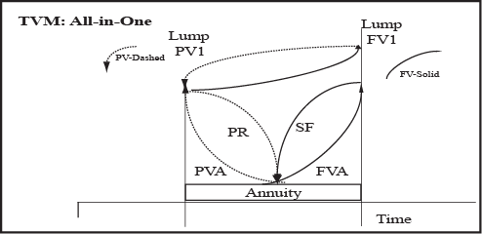

## Alternative Methodologies for TVM Analysis

Before delving into the actual TVM calculations, it should be noted here are a variety of approaches for analyzing problems including:

* Equations. Applying the actual mathematical equations using a basic calculator with exponential functions.
* Financial Calculators. Using a “Financial Analyst” type calculator that has the financial functions and underlying equations preprogrammed.
* Spreadsheet. Using Excel or some other spreadsheet using the raw mathematical equations or using the built-in financial functions.

While each of these methodologies has advantages and disadvantages, if applied correctly, the solutions will be the same. Thus, in order to solve problems, one will have to master the chosen methodology (or be able to follow examples to plug in numbers). However, it should be noted the ability to merely plug in numbers will only work for basic problems that are presented to the analyst in a clear, unambiguous manner. While this might appear to be a reasonable expectation, in reality you will discover TVM problems –especially in real estate—are generally more complex, involving two or more TVM functions. Thus, in approaching real estate decisions, an analyst must be able to set up a problem and lay out the pattern of cash flows including nature (i.e., lump or annuity), amount, timing, and appropriate compounding or discounting rate. Thus, if you merely learn how to blindly plug numbers into a calculator or spreadsheet, you will quickly find yourself confounded by all but the most basic problems. On the other hand, understanding how to dissect a problem statement involving money and time, and set up a solution will enable you to objectively analyze the most complex problems. The balance of this guide and related cases, lecture, tutorials, and interactive problems are designed to help you cultivate this understanding. Due to the relationships among the 6 Functions of $, you will find a degree of intellectual synergy that will make learning more efficient, and more robust.

## Graphical Representation of 6 Functions of $

To help you understand the relationships among the 6 Functions of a $, it is useful to look at a standardized set of assumptions. Exhibit 3 depicts each of the 6 Functions using a constant set of assumptions regarding amounts, rates, and timing which consist of:

* Amount . $1,000 for Lump or $200 spread over 5 payments for Annuity (i.e., $1,000/5)
* Term. 5 years
* Periodicity. Annual

**Exhibit 4 (a): Graphical Representation of 6 Functions of $**



It should also be noted that some of the problems are reciprocals (e.g., FV1-PV1, FV1/P-SF, and PV1/P-PR). This will be important when you are using Excel to solve problems as the basic functions will used in multiple application.

**Exhibit 4 (b): Narrative Snapshot of 6 Functions of $**

|  |  |  |
| --- | --- | --- |
| **FV1: Future Value of Lump**  The FV1 asks the basic question, “What will $1 invested today grow to if it earns interest at some stated rate over some finite time period?”  In order to use the function, substitute the current $’s in the place of the $1, and specify the Rate and Time. |  | **PV1: Present Value of Lump**  The PV1 asks the basic question, “What will $1 received in the future be worth in current dollars if it erodes in value at some stated rate over some finite time period?”  In order to use the function, substitute the actual $’s received in the future in the place of the $1, and specify the Rate and Time. |
|  |  |  |
| **FV1/P: Future Value of Fixed Payments**  (aka FVA: Future Value of Annuity)  The FVA asks the question, “What will $1 in fixed interval payments invested each period grow to if it earns interest at some stated rate over some finite time period?” It differs from the FV1 in the sense that the amount is invested in equal amounts at fixed intervals rather than all up front in one lump sum payment.  In order to use the function, substitute the actual annuitized $’s in place of the $1, and specify the Rate and Time. |  | **PV1/P: Present Value of Fixed Payments**  (aka PVA: Present Value of Annuity)  The PVA asks the question, “What will $1 received at fixed intervals receipts be worth today in terms of current dollars (i.e., purchasing power) if inflation occurs at some stated rate over a finite time period?” It differs from the PV1 in the sense that the amount being eroded is received at fixed intervals rather than all at the end of the period.  In order to use the function, substitute the actual annuitized $’s in place annuitized of the $1, and specify the Rate and Time. |
|  |  |  |
| **SF: Sinking Fund**  The SF asks the basic question, “What equal amount will I have to deposit each period to grow to some targeted Future Value if it earns some stated rate over some finite time period?” It differs from the other functions in that it is looking forward to earning or accruing to a targeted amount by making a series of fixed payments/deposits which are compounded forward, earning interest on the interest.  In order to use the function, substitute the actual lump $’s targeted at some point in the future in place of the $1, and specify the Rate and Time. |  | **PR: Periodic Repayment**  The PR asks the basic question, “If I borrow $1 today, what equal amount will I have to pay each period to repay that amount plus the interest owed on the outstanding balance if I pay some stated rate over some finite time period?” It differs from the other functions in the sense that it is designed to provide a return of (i.e., repay) and a return on (i.e., interest) over the finite period thus reducing the balance to zero. This is also known as a fixed rate, fully amortizing loan.  In order to use the function, substitute the actual $’s borrowed today in place of the $1, and specify the Rate and Time. |

In this primer, we will explore a number of set-ups for the calculating the core TVM functions. In Excel, we will demonstrate the answers using two approaches: 1) prompted functions, and 2) raw built-in functions. At first, you may be more comfortable using the prompts, but as you get more comfortable, you will find it much more efficient to use the raw functions. To make it easier to follow, we have named the various TVM inputs using Excel’s naming option. Exhibit 4 (c) presents the names we assigned. They are also presented in the accompanying Excel file.

**Exhibit 4 (c): Assigned Excel Names for TVM Equations**

# Detailed Review of 6 Functions of $1

## FV1: Future Value of Lump

**TVM Question.** The FV1 asks the basic question, “What will $1 invested today grow to if it earns interest at some stated rate over some finite time period?” The future value of a $1 is the value of a present amount of money at some point in the future.

In order to use the function in problem solving with real numbers, just substitute the current $’s in the place of the $1, and specify the Rate and Time.

**Exhibit 5: FV1**

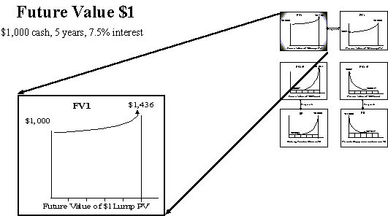

As noted in Equation 1, the default assumption for all TVM problems, including FV1 is that the earnings are compounded forward rather than treated as simple interest. Thus, the key component of all TVM equations becomes:

(1 + i)t

Where :

“i” stands for the interest rate; this may also be denoted “r” or “R” in some examples.

“t” stands for the Term. Note the Term is adjusted for Periodicity so, if monthly, a 5 year period translates to a “t” of 60 (i.e., 5 * 12).

**Table 2 (a): FV $1**



**Table 2 (b): FV Payment in Advance**



**Table 2 (c): FV1 Equations for Alternative Methodologies**

|  |  |
| --- | --- |
| Math | =+(FV_PV)*((1+(FV_i)/(FV_m)))^((FV_t)*(FV_m)) |
| Excel | =FV(FV_i/FV_m,FV_t*FV_m,0,-FV_PV) |
| WebCT | {a}*((1+({i}/100/{m}))**({t}*{m})) |

**Table 2 (d): HP Answer to FV1**

|  |  |  |  |
| --- | --- | --- | --- |
| **Factor** | **Code** | **Initial** | **Answer** |
| Compounding/Period | m | 1 |  |
| Term | t | 5 |  |
| Present Value | PV | $1,000 |  |
| Payment | PMT | $0.00 |  |
| Future Value | FV |  | $1,435.63 |
| Interest Rate | I | 7.50% |  |

Method Steps: HP 10BII

* First, clear all by pressing the GOLD key and then the C ALL key.
* Second, tell the HP that you want to work annually by entering 1, pressing the GOLD key, and then P/YR. (NOTE: this should stay the default from the previous until you change it; clearing the registers does not affect this default).
* Third, enter 5, press the GOLD key, and then press X P/YR.
* Fourth, enter 7.5, press the GOLD key, and then press Nom%.
* Fifth, enter 1,000, and then press PV. Finally, press FV to solve.

**Exhibit 6 (a): Prompted Excel Solutions: FV1**

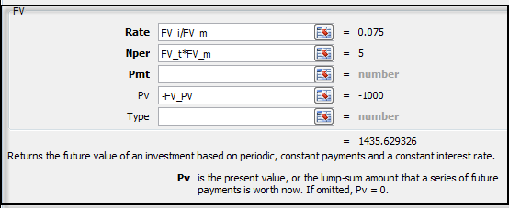

It should be noted that Excel uses the same prompts for calculating the Future Value of a dollar lump (FV1) and the Future Value of an Annuity (FVA). Within Excel, the difference is whether the input is the Pv or the Pmt. Thus, it is important to ensure that you are plugging the inputs into the correct location. In the raw function, each of the variables is delineated by a comma. Thus, it is important to ensure that you place the respective inputs in the correct locations. The good news is that Excel highlights the variables in the equation as you plug them in. Also, the =FV will return a negative number to indicate it is the outlay that corresponds to the future benefit. It can be converted to a positive by leading with =-FV. The [(type)] variable allows you to specify whether the payments are made at the beginning or end of the period; usually, they can be left blank unless the payment is does not follow the defalt or normal conventions. This is the raw FV function:

**Exhibit 6 (b): Raw Excel FV Function**

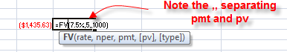

## FVA: Future Value of Annuity

(aka FV1/P: Future Value of Fixed Payment)

**TVM Question.** The FVA asks the question, “What will $1 in fixed interval payments invested each period grow to if it earns interest at some stated rate over some finite time period?” It differs from the FV1 in the sense that the amount is invested in equal amounts at fixed intervals rather than all up front in one lump sum payment.

In order to use the function, substitute the actual annuitized $’s in place of the $1, and specify the Rate and Time.

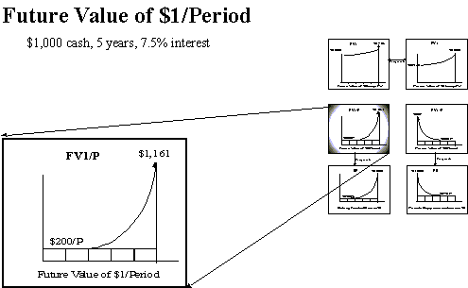

**Exhibit 7: FVA**

The future value of an annuity ($1/period) is the amount that accumulated by a series of equal payments at interest over a period of time

**Types of FVA Problems**

There are two types of FVA problems: payment in advance or at the beginning of each period; or, payment in arrears in which payments are made at the end of the period.

**FV Annuity in Advance.** In the case of an annuity in advance, we would receive the first payment immediately and the rest at the beginning of each period compounding forward to a future lump sum.

**Table 3 (a): FV Annuity in Advance**



**Table 3 (b): Annuity in Advance Schedule**



**FV Annuity in Arrears.** In the case of an annuity in arrears, we would receive the payments at the end of each period compounding forward to a future lump sum.

**Table 3 (c): FV Annuity in Arrears**



**Table 3 (d): FV Annuity in Arrears Schedule**



**Table 3 (e): FVA Equations for Alternative Methodologies**

|  |  |
| --- | --- |
| Math | =+(FVA_PMT)*((((1+((FVA_i)/(FVA_m)))^(FVA_t*FVA_m))-1)/(FVA_i/FVA_m)) |
| Excel | =FV(FV_i/FV_m,FV_t*FV_m,,-FV_PV) |
| WebCT | {a}* (((1+({i}/100/{m}))**({t}*{m}))-1)/(({i}/100/{m})) |

**Table 3 (f): HP Solutions 2: FVA**

|  |  |  |  |
| --- | --- | --- | --- |
| **Factor** | **Code** | **Initial** | **Answer** |
| Compounding/Period | m | 1 |  |
| Term | t | 5 |  |
| Present Value | PV | $0 |  |
| Payment | PMT | $200 |  |
| Future Value | FV |  | $1,161.68 |
| Interest Rate | I | 7.50% |  |

Method Steps: HP 10BII

* First, clear all by pressing the GOLD key and then the C ALL key.
* Second, tell the HP that you want to work annually by entering 1, pressing the GOLD key, and then P/YR. (NOTE: this should stay the default from the previous until you change it; clearing the registers does not affect this default)
* Third, enter 5, press the GOLD key, and then X P/YR.
* Fourth, enter 7.5, press the GOLD key, and then NOM%.
* Fifth, enter 200 and then press PMT
* Sixth, press FV to get answer.

**Exhibit 8 (a): Prompted Excel FVA in arrears**

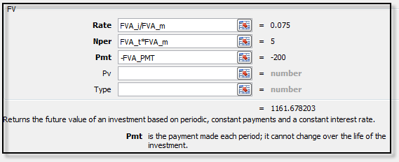Note that Excel uses the same prompts for FV and FVA; difference is in use of Pmt vs. Pv. The default in HP10BII and Excel is to treat it as an annuity in arrears which is the typical industry practice.



**Exhibit 8 (b): Prompted Excel FVA in advance**

To change it to an Annuity in Advance, the “Type” is noted as below.

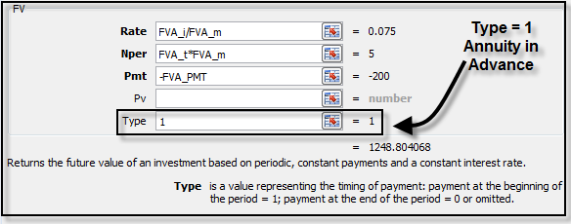

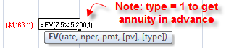

## SF: Sinking Fund

**TVM Question.**The SF asks the basic question, “What equal amount will I have to deposit each period to grow to some targeted Future Value if it earns some stated rate over some finite time period?” It differs from the other functions in that it is looking forward to earning or accruing to a targeted amount by making a series of fixed payments/deposits which are compounded forward, earning interest on the interest.

In order to use the function, substitute the actual lump $’s targeted at some point in the future in place of the $1, and specify the Rate and Time.

**Exhibit 9: Sinking Fund**

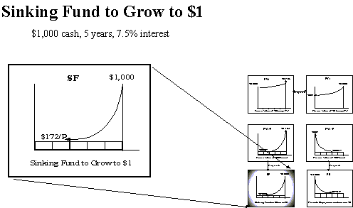

**Types of SF Payments**

As in the case of the FVA, there are two types of SF problems: payment in advance or at the beginning of each period; or, payment in arrears in which payments are made at the end of the period. Note that the SF is the reciprocal of the FVA

**SF Annuity in Advance.** In the case of an annuity in advance, we would receive the first payment immediately and the rest at the beginning of each period compounding forward to a future lump sum. In our case:

**Table 4 (a): SF Annuity in Advance**



**Table 4 (b): SFAnnuity in Advance Schedule**



**SF Annuity in Arrears.** In the case of an annuity in arrears, we would receive the payments at the end of each period compounding forward to a future lump sum. In our case:

**Table 4 (c): SF Annuity in Arrears**



**Table 4 (d): SF Annuity in Arrears Schedule**



**Table 4 (e) SF Annuity Equations for Alternative Methodologies**

|  |  |
| --- | --- |
| Math | =+(SF_FV)*((SF_i/SF_m)/(((1+(SF_i)/SF_m))^(SF_t*SF_m)-1)) |
| Excel | =PMT(SF_i/SF_m,SF_t*SF_m,,-SF_FV) |
| WebCT | {a}*(({i}/100/{m})/(((1+({i}/100/{m}))**({t}*{m}))-1)) |

**Table 4 (f): HP Solution to SF**

|  |  |  |  |
| --- | --- | --- | --- |
| **Factor** | **Code** | **Initial** | **Answer** |
| Compounding/Period | m | 1 |  |
| Term | t | 5 |  |
| Present Value | PV | $0 |  |
| Payment | PMT |  | $172.16 |
| Future Value | FV | $1,000 |  |
| Interest Rate | I | 7.50% |  |

Method Steps: HP 10BII

* First, clear all by using the GOLD key and then the C ALL key.
* Second, tell the HP that you want to work annually by entering 1, pressing the GOLD key, and then press P/YR. (NOTE: this should stay the default from the previous until you change it; clearing the registers does not affect this default).
* Third, enter 5 and then press the GOLD key and then X P/YR.
* Fourth, enter 7.5, press the GOLD key and then NOM%.
* Fifth, enter 1,000 and then press FV
* Sixth, press PMT to get answer.

**Exhibit 10 (a): Prompted Excel SF (arrears)**

Note that the SF is the reciprocal of the FVA. Excel uses the same prompts for FV and FVA; difference is in use of Pmt vs. Pv. The default in HP10BII and Excel is to treat it as an annuity in arrears which is the typical industry practice.

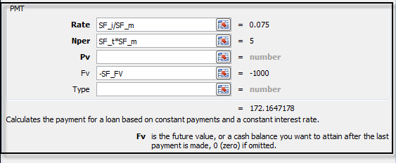

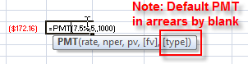

**Exhibit 10 (b): Prompted Excel SF (advance)**

To change the SF to an Annuity in Advance, the “Type” is noted as below. Note the payment is smaller since it will compound an additional period.

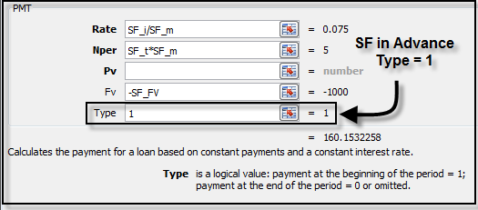

## 



## PV1: Present Value of Lump

**TVM Question.**The PV1 asks the basic question, “What will $1 received in the future be worth in current dollars if it erodes in value at some stated rate over some finite time period?”

In order to use the function, substitute the actual $’s received in the future in the place of the $1, and specify the Rate and Time.

**Exhibit 11: PV1**

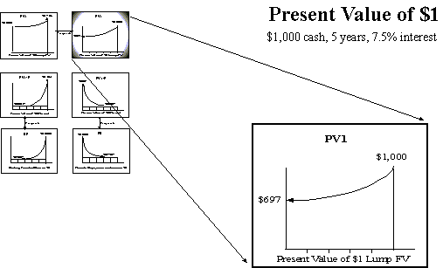

**Table 5 (a): Equation for PV1**



**Table 5 (b): PV1 Schedule**



**Table 5 (c): PV1 Equations for Alternative Methodologies**

|  |  |
| --- | --- |
| Math | =+(PV_FV)*((1/((1+(PV_i/PV_m))^(PV_t*PV_m)))) |
| Excel | =PV(PV_i/PV_m,PV_t*PV_m,,-PV_FV) |
| WebCT | {a}*(1/((1+({I}/100/{m}))**({t}*{m}))) |

**Table 5 (d): HP Solution for PV1**

|  |  |  |  |
| --- | --- | --- | --- |
| **Factor** | **Code** | **Initial** | **Answer** |
| Compounding/Period | m | 1 |  |
| Term | t | 5 |  |
| Present Value | PV |  | $696.56 |
| Payment | PMT | $0.00 |  |
| Future Value | FV | $1,000 |  |
| Interest Rate | I | 7.50% |  |

Method Steps: HP 10BII

* First, clear all by pressing the GOLD key and then the C ALL key.
* Second, tell the HP that you want to work annually by entering 1, pressing the GOLD key, and then P/YR. (NOTE: this should stay the default from the previous until you change it; clearing the registers does not affect this default).
* Third, enter 5, press the GOLD key, and then X P/YR.
* Fourth, enter 7.5, press the GOLD key, and then NOM%.
* Fifth, enter 1,000 and then press FV
* Sixth, press PV to get answer.

**Exhibit 12: Prompted Excel PV1**

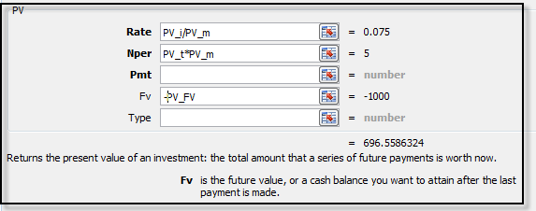

Note both HP10B and Excel assume the receipt is at the “END” of the Term and is brought back to today, the beginning point.



## PVA: Present Value of Annuity (aka PV1/P)

**TVM Question..**The PVA asks the question, “What will $1 received at fixed intervals receipts be worth today in terms of current dollars (i.e., purchasing power) if inflation occurs at some stated rate over a finite time period?” It differs from the PV1 in the sense that the amount being eroded is received at fixed intervals rather than all at the end of the period.

In order to use the function, substitute the actual annuitized $’s in place annuitized of the $1, and specify the Rate and Time.

**Exhibit 12: Present Value Annuity PVA**

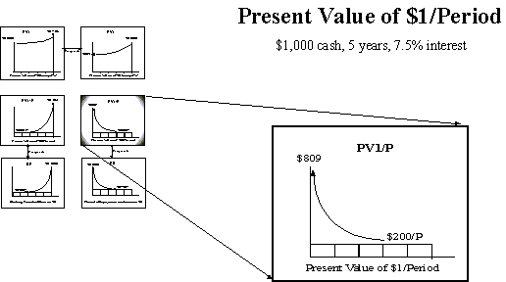

**PV Annuity in Arrears.** In the case of PV Annuity problems, the default assumption is payments in arrears.

**Table 6 (a): PV Annuity in Arrears**



**Table 6 (b): PVA Equations for Alternative Methodologies**

|  |  |
| --- | --- |
| Math | =+(PVA_PMT)*((1-(1/((1+(PVA_i/PVA_m))^(PVA_t*PVA_m)))))/(PVA_i/PVA_m) |
| Excel | =PV(PVA_i/PVA_m,PVA_t*PVA_m,-PVA_PMT) |
| WebCT | {a}*(1-(1/(1+({i}/100)/{m})**({t}*{m})))/(({i}/100)/{m}) |

**Table 6 (c): HP Solution to PVA**

|  |  |  |  |
| --- | --- | --- | --- |
| **Factor** | **Code** | **Initial** | **Answer** |
| Compounding/Period | m | 1 |  |
| Term | t | 5 |  |
| Present Value | PV |  | $809.18 |
| Payment | PMT | $200 |  |
| Future Value | FV | $0 |  |
| Interest Rate | I | 7.50% |  |

Method Steps: HP 10BII

* First, clear all by pressing the GOLD key and then the C ALL key.
* Second, tell the HP that you want to work annually by entering 1, pressing the GOLD key, and then the P/YR. (NOTE: this should stay the default from the previous until you change it; clearing the registers does not affect this default)
* Third, enter 5, press the GOLD key, and then X P/YR
* Fourth, enter 7.5, press the GOLD key, and then NOM%.
* Fifth, enter 200 and then press PMT
* Sixth, press PV to get answer

**Exhibit 13 (a): Prompted Excel PVA in arrears**

Note the difference between End and Beginning of Period (i.e., arrears or advance). The default is in arrears. In this case, the treatment of timing is material in this example since the periodicity is annual and the term is short. If it was monthly and longer term, the differences would typically be immaterial.

## 



**Exhibit 13 (b): Prompted PVA in advance**

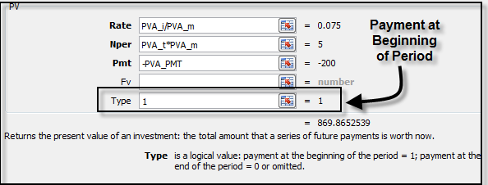



## PR: Periodic Repayment to Amortize $1

**TVM Question.** The PR asks the basic question, “If I borrow $1 today, what equal amount will I have to pay each period to repay that amount plus the interest owed on the outstanding balance if I pay some stated rate over some finite time period?” It differs from the other functions in the sense that it is designed to provide a return of (i.e., repay) and a return on (i.e., interest) over the finite period thus reducing the balance to zero. This is also known as a fixed rate, fully amortizing loan.

In order to use the function, substitute the actual $’s borrowed today in place of the $1, and specify the Rate and Time.

**Exhibit 14: Periodic Payment (aka Periodic Repayment PR)**

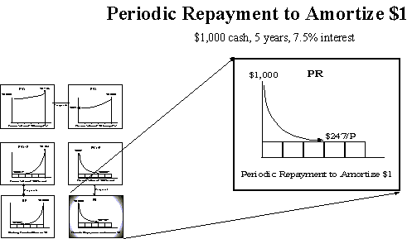

In the case of Periodic Repayment problems, the default assumption is payments in arrears.

**Table 7 (a): PR in Arrears**

**Table 7 (b): PR Equations for Alternative Methodologies**

|  |  |
| --- | --- |
| Math | =+(PR_PV)*((PR_i/PR_m)/((1-(1/((1+(PR_i/PR_m))^(PR_t*PR_m)))))) |
| Excel | =PMT(PR_i/PR_m,PR_t*PR_m,-PR_PV) |
| WebCT | {a}*(({i}/100)/{m})/(1-(1/(1+({i}/100)/{m})**({t}*{m}))) |

**Table 7 (c): HP Solution for PR**

|  |  |  |  |
| --- | --- | --- | --- |
| **Factor** | **Code** | **Initial** | **Answer** |
| Compounding/Period | m | 1 |  |
| Term | t | 5 |  |
| Present Value | PV | $1,000 |  |
| Payment | PMT |  | $247.16 |
| Future Value | FV | $0 |  |
| Interest Rate | I | 7.50% |  |

Method Steps: HP 10BII

* First, clear all by pressing the GOLD key and then the C ALL key.
* Second, tell the HP that you want to work annually by entering 1 and then pressing the GOLD key followed by the P/YR. (NOTE: this should stay the default from the previous until you change it; clearing the registers does not affect this default).
* Third, enter 5, press the GOLD key, and then press X P/YR.
* Fourth, enter 7.5, press the GOLD key, and then press NOM%.
* Fifth, enter 1,000 and then press PV.
* Sixth, press PMT to get answer.

**Exhibit 17: Excel Prompted PR**

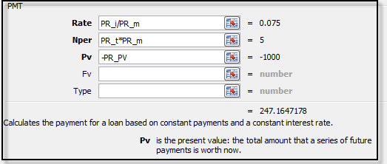

# Conclusion

As noted throughout this guide, TVM problems can be reduced to some simple concepts. The core equation for all calculations remains:

(1 + i)t

By understanding this equation, you should have an appreciation for the power of compounding and the importance of using TVM calculations to support decision-making in real estate, and in many other contexts where time and money are involved.

Once again, the essence of TVM can be summarized in Exhibit 18 which replicates Exhibit 3. When you saw the initial exhibit, it probably appeared to be a complex set of lines, arrows and acronyms. At this point, it should now be something you can dissect and understand at a basic component level. The only way to know if you have the requisite understanding to be able to solve TVM problems is to practice. Based on this primer, you should have a solid foundation upon which to build your problem-solving skills. Good luck and have fun be with your calculator, Excel or pen and pencil. As they say, the devils in the details and real estate deals are no exception.

**Exhibit 18: TVM All-in-One Six Functions of $**

