Case 5: Discounted Cash Flow (DCF) Analysis
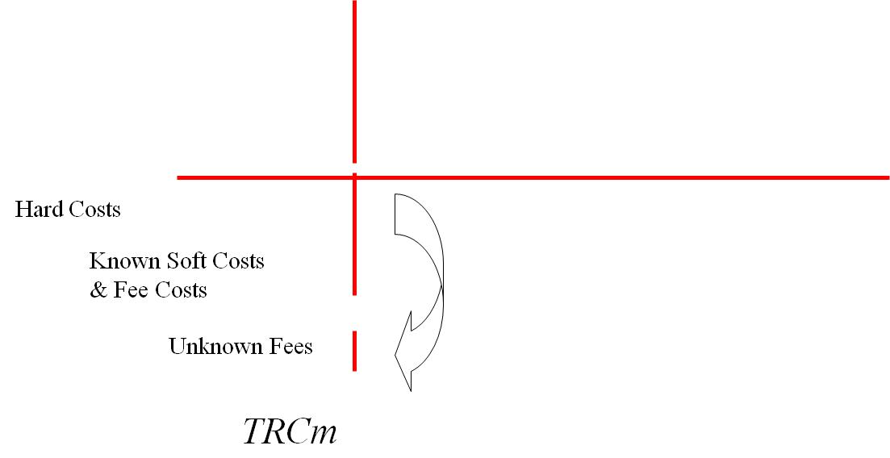



TRCm
Frontdoor/
Backdoor
Building
Envelope
(BSF)

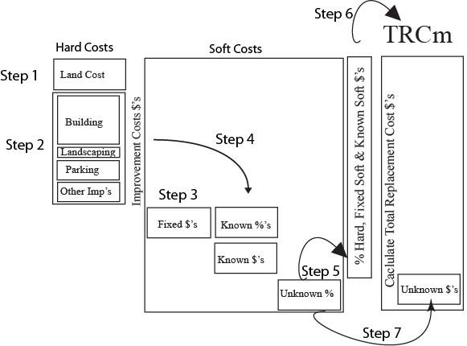



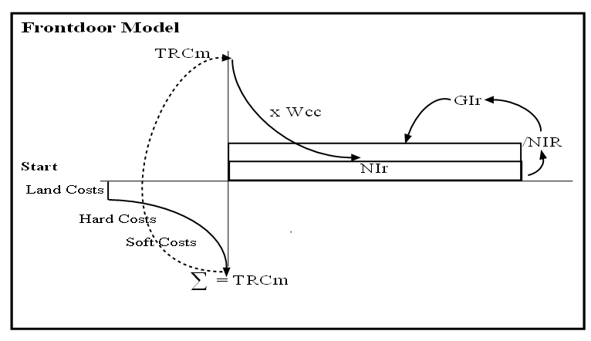
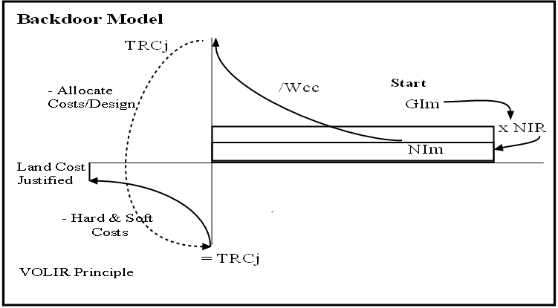

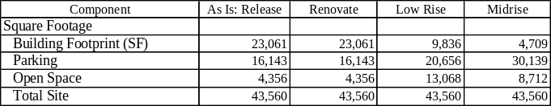

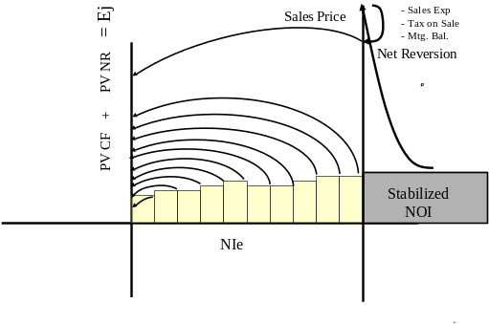

Case Objective

To this point, we have explored alternative development scenarios for a site using three basic tools: Building Envelope Analysis, Total Replacement Cost Analysis, and Frontdoor/Backdoor Analysis. These basic tools were then combined into the Integrated Alternative Use model which provided an efficient solution for exploring a number of use options, ranging from the re-use of an existing building to the development of new facilities. Once the analyst has selected one or more potentially viable development solutions, the project(s) can be subjected to more precise financial analysis. Discounted Cash Flow (DCF) analysis is the tool that analysts typically apply to explore whether the proposed project is likely to generate sufficient risk-adjusted returns. This more in-depth analysis focuses on financial assumptions, cash flows, risk exposures, and returns that would be imposed by potential lenders and investors.

Discounted Cash Flow (DCF) is a standard analytical framework for multi-period real estate investment analysis. The approach has some advantages over more static approaches (i.e., cap rate analysis, Frontdoor/Backdoor Analysis) in the sense that it adds more flexibility and more precision to real estate investment analysis. This is especially true in terms of differential cash flows that typify actual real estate investments due to differential rates of change that apply to key financial variables over time. In addition, different rent rolls and leases create changes in cash flow due to renegotiations attendant with lease renewals and changing terms associated with new leases. In addition, leases have a variety of variables that can change the level of gross income (i.e., indexed leases) as well as the level and allocation of operating expenses, requirements for tenant improvements, land changing loan amortization schedules that trigger changes in net operating income and net terminal values. The objective of this case is to present the structure and calculation of a basic DCF model, as well as explore some of the key ratios that can be used in investment analysis. The analysis is based on inputs generated from a Backdoor Analysis, suggesting that the DCF should provide acceptable returns under general market conditions.

The DCF Excel model presented herein is a relatively straightforward cash flow model. The model can be modified through the addition of a number of bells and whistles to increase its precision or account for the nuances of a proposed project (e.g., multiple buildings, phased construction, mixed-use projects, rent rolls). It can also be used to explore the marginal returns and cost/benefit of various options for existing buildings –green building, capital expenditure programs, renovation or rehab-- to investors. Similarly, it can be used to explore various financial structures (e.g., partnerships, multiple mortgages) or ownership options. It should be noted that Argus and other canned DCF packages-- can accommodate more in-depth financial modeling and can replicate actual rent roll, financial structuring and other options that may be used to financially engineer a project. However, without an understanding of the basic structure of DCF as presented in this case, such analysis can quickly become a black box subject to the old axiom “garbage in, garbage out.” Thus, before getting caught up in the idiosyncratic steps necessary to run Argus and other models, it is important to understand the basic mechanics of DCF modeling.

Table of Contents
Organization 1
Project Overview 1
Discounted Cash Flow (DCF): A Graphical Overview 2
DCF Input Assumptions 5
Total Replacement Cost from Market (TRCm) 6
Income/Operating Assumptions 6
Mortgage Terms 7
Project Attributes 7
Equity Assumptions 8
Limitations and Caveats in DCF Modeling 8
Organization 10
Schedule I 10
Schedule I Snapshot 10
Year 1 Assumptions 13
Schedule I: GI to NOI 13
Schedule I: NOI to Before Tax Cash Flow 16
Supporting Schedules II-V 17
Schedule II: Depreciation 17
Schedule III: Loan Amortization 18
Schedule IV: Capital Gain Tax on Sale 20
Schedule V: Net Reversion; After Tax, After Sale Proceeds 21
Schedule VI: Financial Ratios 22
Debt Coverage Ratio (DCR) 24
Default Ratio 25
Profitability Index (PI) 26
Before Tax Cash on Cash (CoC) Return 27
After Tax Cash on Cash (CoC) Return 28
Implicit Cap Rate 29
Gross Income Multiplier (GIM) 30
Net Income Multiplier (NIM) 31
Payback Ratio (w/o sale) 32
Modified Payback Ratio (w/o sale) 33
Net Present Value 34
Marginal Rate of Return 35
Schedule VII: IRR & MIRR 36
Overview of IRR 36
Overview of MIRR 38
DCF Conclusion 39

Organization

Project Overview
To provide continuity across cases and allow students to see how they can be linked into a holistic approach, this case focuses on the same project as explored in the Case 1-3 series and reflected in the Case 4, Integrated Alternative Use Analysis. Exhibit 1 presents the proposed Building Envelope generated in Case 1. As noted, the project is a 4-story, 18,837 square foot building. The Total Replacement Cost is some $3.88 million (Exhibit 1 (b). Given this scenario, the Frontdoor model generates an average Gross Income/SF of $24.87 based on 80% loan at 7.5% interest and an equity cap rate of 10%. As noted in the Frontdoor/Backdoor Case, if the outputs from the simplified, “annuitized” models are plugged into a DCF as inputs, the project will be financial “feasible.” Thus, assuming that premise holds, if the required rents can be achieve, the project should “work.”

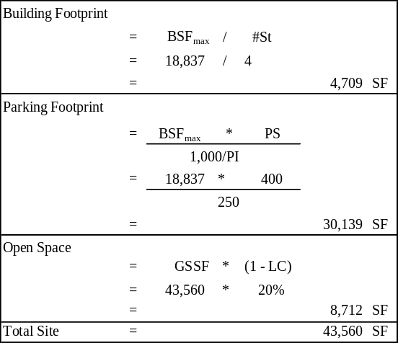
Exhibit 1 (a): Proposed Building Envelope
Exhibit 1 (b): Total Replacement Cost
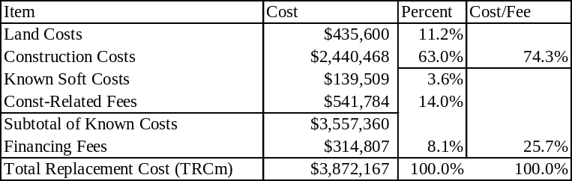

Exhibit 1 (c): Gross Income Required
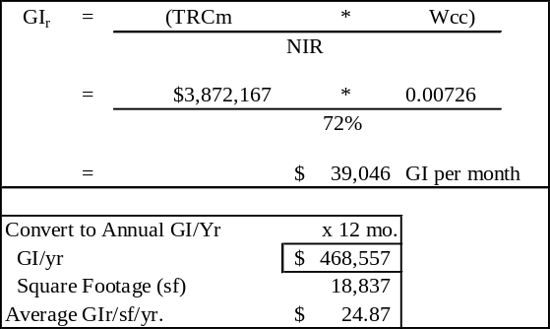

Discounted Cash Flow (DCF): A Graphical Overview

On the surface, Discounted Cash Flow analysis might appear to be rather complicated. This caveat is especially true if one merely jumps into a canned package and begins pulling down some drop-down menus. If DCF is approached that way, it is easy to get mired in myopia, focusing on learning where to plug the inputs rather than learning how to interpret the outputs or testing various assumptions. Thus, a novice analyst who figures out where to put the inputs can be drawn into a false of confidence, measuring success by merely mastering the inputs, and then focusing on some of the outputs such as the Internal Rate of Return (IRR) that pops out. The reality is that DCF analysis is relatively straightforward, involving series of tables or schedules that are generated through a number of mathematical equations. Indeed, the most complicated financial calculations are the mortgage math which is essentially generated by the Periodic Repayment factor and the IRR which is simply a Time-Value-of-Money calculation. After working through this case, readers should come to the same conclusion. At that point, then an analyst can properly add value by focusing attention on the validity of input assumptions rather than the mathematics of the model.

Exhibit 2 indicates how the Frontdoor/Backdoor can be used to solve for a balanced project in which the Value (TRCj = TRCm) and the Income (GIr = GIm) at the required rate of return. That is, the cost justified by the rents equals the cost necessary to develop the project, and the income required equals the likely income that can be supported by the market demand. While the analysis looks simple when stripped down to this level, it visually represents a much more complicated analysis which focuses on the market support which ultimately determines the long-term success of a project.

Exhibit 2 (a): Frontdoor/Backdoor Balanced Model

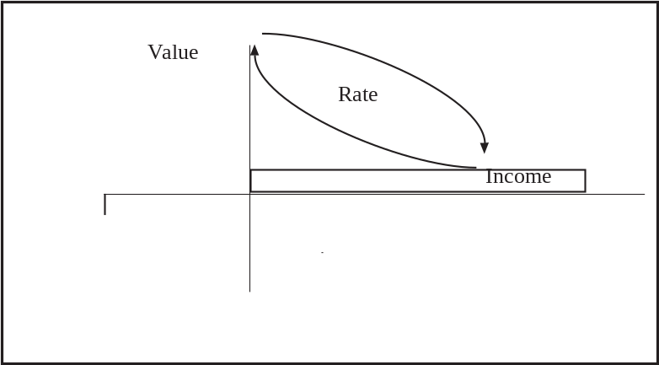

As noted in the exhibit, the Frontdoor/Backdoor models assume that Net Income from the Market (NIm) is received as an annuity; that is, it is a fixed amount that continues in perpetuity. Given that simplifying assumption, the Total Replacement Cost Justified (TRCj) is the Present Value of the NIm which is calculated by dividing it by the Weighted Cost of Capital (Wcc). The Wcc is the weighted cost of capital that comes from two sources; debt and equity using the Loan to Value (LV) ratio to allocate between the two sources. As noted in the following equation, the Mortgage Coefficient (Mc) and Equity Constant (Ec) representing the required, annuitized rate of return for the respective parties.


One of the main differences between a DCF and the annuitized Frontdoor/Backdoor models is recognition that Net Income levels are likely to change over time, thus preempting the use of a simplified annuity rate of return. Exhibit 2 (b) presents a pattern that the NI for a project might actually experience, with a series of uneven steps as tenants roll over, expenses are incurred and other operational items affect annual receipts. Since these receipts are unequal, they are converted to a Present Value (PV) by calculating the value of each lump sum receipt, and then aggregating them together. The Unleveraged DCF model also recognizes that in addition to periodic cash flows, an investor in a real estate project typically benefits from a positive lump sum receipt upon sale. This future receipt is the “After Tax Net Reversion” which is also denoted the Net Reversion (NR).

The NR is calculated by capitalizing Net Income, drawing on the basic V = I/R which is at the heart of the Frontdoor/Backdoor models. That is, an investor is likely to pay the value of the expected income at any point in time. In DCF analysis, the Income that is capitalized is typically the stabilized Net Operating Income (NOI) which is the average net income level over several years. The use of “stabilized” NOI eliminates the potential volatility that could be generated by capping income that experiences temporary fluctuations due to rent rolls, vacancy, non-recurring expenses or other factors. The “cap” rate at which the income is value is known as the Exit Cap Rate, which is the future analog to the Going-in Cap Rate. Once the Gross Sales Price is determined, the costs of sale including sales expenses and capital gains taxes on sale are deducted to arrive at the Net Reversion (NR). This future lump sum receipt is then discounted back to the present and then added to the aggregate present value of the periodic cash flows to calculate the present value (PV) of the expected or proforma benefits. Since estimate the value of the project to the equity investor. This is also the Equity Justified (Ej) which is what the investor should put into the investment.

Exhibit 2 (b): Graphical Unleveraged DCF Model
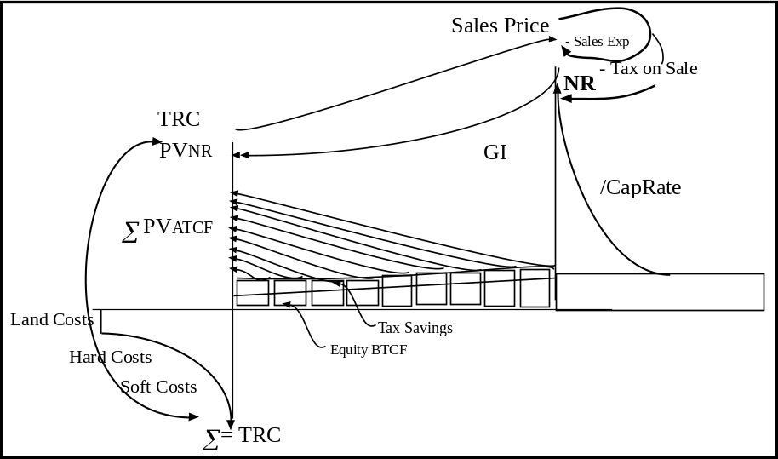

As noted in Exhibit I-C, the Net Income (NI) in a leveraged investment includes an allocation to the lender, typically in the form of an annuitized payment of principle and interest. A DCF Model also adds another layer of precision to the analysis, factoring in federal income taxes to arrive at a more accurate view of the equity investor’s return from a project. Thus, tax deductions are used to reduce NI to a Taxable Income (TI), allowing recognition of the tax benefits or costs associated with an investment. Since some tax deductions are allowances rather than actual outlays, once the taxes are estimated the income is converted back to an After Tax Cash Flow (ATCF) by adding back allowances and non-deductible items. In a similar vein, since leverage is involved, the Net Reversion is the Gross Sales Price less the cost of sales expenses, capital gains taxes on sale, and the outstanding principal balance of any mortgage or mortgages at the time of sale.

Exhibit 2 (c): Graphical Leveraged DCF Model

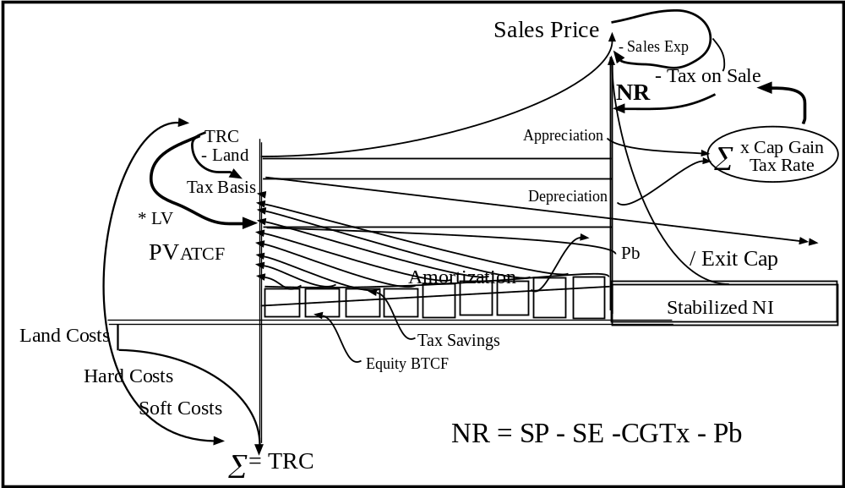

Case Overview

This case study is organized around the major schedules that would typically be included in a DCF model. The base assumptions are summarized in Exhibit 3 including the initial assumptions and the rates of change in selected variables over the forecast period. As noted earlier, this model covers the basic DCF which might be embellished through a number of “add-ons” that would add to its precision.

Exhibit 3: Input Assumptions
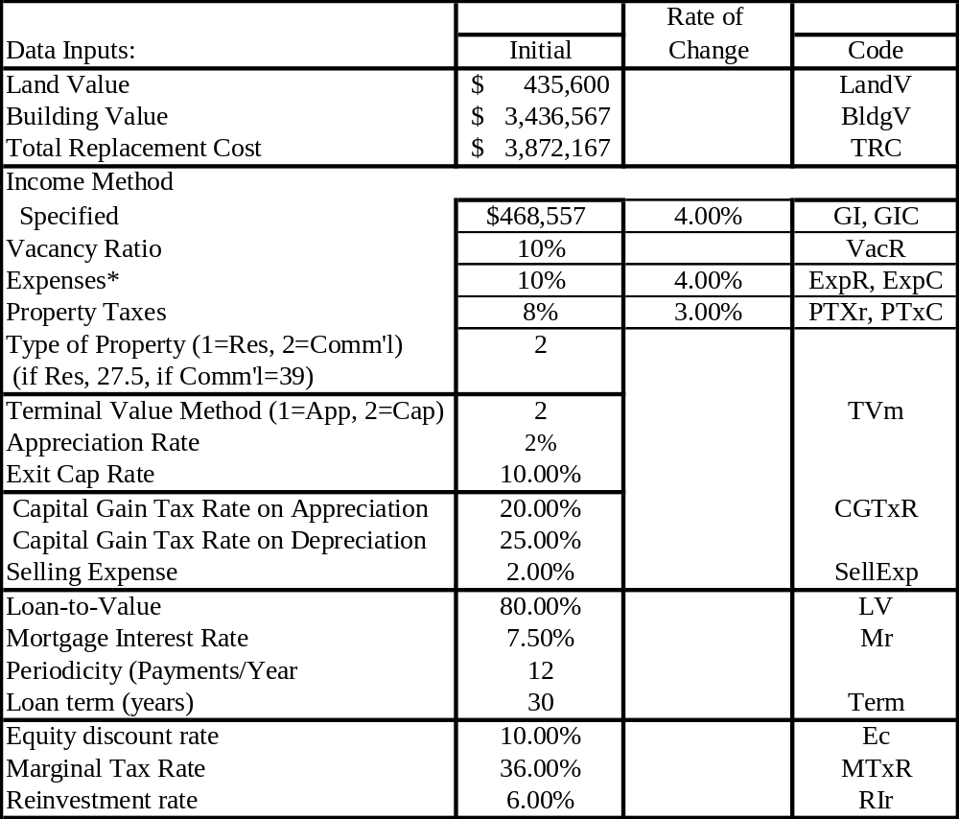

*Includes Reserve Ratio

DCF Input Assumptions

To run a basic DCF model, a number of basic assumptions must be made to “drive” the calculations. Some of these will be givens, dictated by tax law, while others will vary on a project by project basis, depending on market conditions or investor requirements or choices that affect the proforma levels of cash flows, mortgage payments and equity returns. The number of input variables and the level of detail will vary from project to project, depending on its complexity and the nature of the decision for which the DCF analysis is being conducted. The basic types of inputs and the sources which can be used to estimate them include:

Total Replacement Cost from Market (TRCm)
- Definition: The fully-loaded cost to build or buy the proposed development. These costs could be broken down in greater detail. However, for basic DCF the important element is to distinguish between land and buildings/improvements since the latter is depreciable and will affect income taxes.
- Items:
  - Land Costs. All non-depreciable costs associated with acquiring land. In the case of an existing project for which a building is slated for replacement, may include the implicit value of the foregone income the building would have generated.
  - Hard Costs & Soft Costs. Total costs allocated to a building including soft costs that are capitalized into the cost rather than expensed as a current period charge. Includes ancillary structures such as parking ramps and other facilities that can be depreciated.
- Sources: Analysis of the designed facility plus soft costs and land costs extracted from the market as generated in the TRCm model or using third-party services (e.g., Marshall Swift, RS Means for costs). In the case of an existing facility, the allocation between land and buildings may be based on an appraisal or other evidence of relative values including assessed values. It can also be estimated via land comparables or by rules of thumb that establish the relationship between land and building value in a particular submarket, for a particular property type, quality level and intensity of development (e.g., 10%-20% of Total Cost).

Income/Operating Assumptions
- Definition: The set of assumptions regarding the potential income and expenses associated with operating the property. These assumptions include the initial values, as well as the rate of changes over the forecast period.
- Key operating items:
  - Gross Income. The initial Gross Income (GI₁) and income change/year (GIc). These items can be aggregated into a single figure, or broken down by major source of revenue. Such a breakdown can be based on major use categories (e.g., residential vs. retail in a mixed-use building), or types of revenue units which might have different patterns of growth and/or vacancy. Note that in this base-case DCF model, GI also includes “Other Income” from such sources as parking, utility charges, fees and other sources.
  - Vacancy Allowance. The estimated percentage loss of Gross Income due to vacancy and collection allowances. In the case of multiple sources of income, these figures can be presented at an overall level, or at a disaggregated level. Also, the Vacancy in this model is a non-cash item; it is an allowance that is used for pricing a project based on expected performance.
  - Expenses. The Expense figure represents the initial Expense Rate (ExpR) and the expense change/year (ExpC). As with other items, Expenses could be broken down into more precise categories, or allocated between fixed or variable (i.e., required $’s or a function of occupancy). The category may also include other operating costs or allocations, including Reserves for routine maintenance, but not Capital Expenditures which are treated as non-recurring items.
  - Property Taxes. The initial Property Tax Rate (PTXr) and change/year (PTxC). This figure can be based on current tax roles, or on assumed assessed values multiplied by the appropriate mill rate (i.e., $’s/thousand of assessed value). The rationale for isolating it from other expenses is that the growth rate is likely to differ from other items, tracking appreciation in value rather than inflation.
- Sources: Income and Operating assumptions can be estimated from a variety of sources depending on the type of analysis and access to data. When analyzing an existing building, the operating history may provide the most accurate estimates, although such figures will not reflect over or under-maintenance, or levels that deviate from the norm due to tenant behavior rather than operating efficiency. As such, in some cases it is useful to conduct primary market research to extract information from comparable projects, or to turn to operating assumptions from secondary sources including trade associations which may track such items.

    - Retail: Urban Land Institute (ULI), International Council of Shopping Centers (ICSC)
    - Office: Building Owners and Managers Association (BOMA), National Association of Industrial and Office Parks (NAIOP)
    - Apartment: International Real Estate Management Association (IREM)
    - Industrial: Society of Industrial and Office Realtors (SIOR), IREM, NAIOP

Mortgage Terms
- Definition: The terms associated with permanent mortgage debt that is repaid during the operating period. These terms may vary by type of loan, as in the case of fully amortizing loans, for which payment levels including a blended allocation between interest and principal which provide a return “on” and “of” capital. In this simplified case, it is assumed that all mortgages are fully amortizing. As with other items, there could be more than one mortgage, or non-standard types (e.g., interest-only, negative amortization, bullet, variable rate) which would warrant special treatment.
- Key mortgage items:
  - Loan-to-Value (LV) Ratio. The percent of the Market Value or Appraised Value that will be advanced by the mortgagee rather than the investor or equity parties.
  - Nature of Loan (i.e., amortizing, interest-only, bullet). Note these non-standard mortgages are not treated in this model, although they could be incorporated through some modifications.
  - Term. The number of years over which the mortgage is amortized.
  - Periodicity. The number of payments/year which by default, is assumed at 12.
  - Interest Rate. The contract interest rate that is charged for the use of funds and paid on a scheduled, periodic basis.
- Sources: Primary research or actual commitments from lenders, or other capital flows reports or other market-tracking systems, services or publications.

Project Attributes
- Definition: The fundamental project assumptions related to its nature, tax treatment, or future net terminal value. Some of these items are fixed by law (e.g., depreciation method, capital gain taxes) and some are variable (e.g., appreciation rate, selling expenses).
- Key project attributes:
  - Depreciation. This specification is axiomatic for single use properties. For mixed-use projects, the designation will be based on the “primary use.” The current tax laws specify the useful for two types of projects.
    - Commercial: straight-line, 39 year useful life
    - Residential (i.e., multifamily rental): straight-line, 27.5 year useful life
  - Terminal value method. This specification dictates how the Gross Sales Price for future transactions will be calculated. In this model, there are two approaches.
    - Appreciation Rate. This treatment begins with the initial cost or value which is then inflated or deflated by some assumed compound rate of change.
    - Exit Cap Rate. This treatment estimates the Sales Price by capitalizing the subsequent year’s Net Income by the Exit Cap rate. In this case, the latter approach is applied.
  - Selling Expenses: the cost of sale if the property is sold expressed as a percent of sales price.
- Sources: These attributes can be extracted from existing laws and/or accounting principles, extracted through primary market research into comparable projects or based on industry standards or norms.

Equity Assumptions
- Definition: The economic factors used in valuing a project including such items as return requirements, investment opportunities and cost of capital, and income tax rates. These items will vary by investor, actual or most probable
- Items:
  - Equity Discount Rate. The cost of capital or required rate of return that is used for discounting equity benefits (i.e., periodic cash flows, tax shelter, net terminal value) to a present value.
  - Marginal Tax Rate. The assumed income tax rate for the current or most likely investor.
  - Reinvestment Rate. The assumed rate of return at which periodic after tax cash flows can be invested.
- Sources: The equity assumptions can be provided by the current or most likely investor, or by market norms, requirements or assumptions extracted through primary market research or sources who track the real estate industry.

Limitations and Caveats in DCF Modeling

The simplified DCF presented in this handout can support a number of decisions related to project selection, pricing and risk-management. The current structure should be adequate to support initial or intermediate project analysis for comparing and contrasting alternative investments or for making preliminary feasibility decisions. Furthermore, a conceptual understanding of this basic structure is important to more advanced analysis, allowing analysts to understand the direction of changes that various assumptions or adjustments might trigger. Analysts should be aware of the need to modify the basic model to support more complex projects or allow more precision including:

- Rent Rolls. In a multi-tenant property with various leases, the income calculations would be more complicated and have different terms, expense allocations, and rental determinations. This basic DCF could be enhanced by modifying the inputs, or by developing separate leasing and expense schedules that could be laid into the model.
- Financial Engineering. In the case of investments that involve more complicated financing, the equations could be modified or alternative financial schedules could be developed to model various financial structures and make other adjustments to reflect different assumptions or support more precise calculations.
- 10-year Convention and Optimal Holding Period. In general, most DCF models span a 10-year forecast period. On the surface, it might appear that there is some compelling rationale behind such a convention. In reality, the use of the 10-year convention is an artifact of technology at the time computer-based DCF models were developed in the 1960s. At the time, computer applications were written on mainframe computers, using punch cards for inputs, and high-speed burst printers for output. The printouts were upper case only, could not handle alternative character sets, and were limited to 132 characters per line. Since 22 characters or so were needed to label variables (e.g., gross income, depreciation), and columns had to be separated by spaces, only 10 years could be squeezed onto a single sheet. This brief sojourn down memory lane is significant in the sense that the appropriate time period for analyzing real estate investments varies by type, scale, market cycle and nature of holding or investment strategy. When combined with the pattern of returns and marginal benefits from holding an additional year, the optimal holding period may be shorter or longer than the 10-year convention. To support such decision-making, the DCF presented in this case provides annual returns and benefit analysis with and without sale in each of the 10 years. The model can also be easily extended to accommodate longer term holds which may be indicated by the duration of leases, or the need to avoid fluctuating terminal value calculations associated with the anomaly of rent rolls or other considerations.
- Absence of Industry Standard DCF. It should be noted that there are a number of commercial DCF models on the market --each with different levels of precision and flexibility-- that can be bought off-the-shelf. At the same time, there is an infinite array of proprietary “Excel” spreadsheets that have been developed by individuals and companies to accommodate their personal preferences or analytical requirements. This proliferation of models, coupled with the absence of a dominant industry model, creates a confusing array of analytical techniques and models that are used in pricing real estate or analyzing investments. In addition to the array of financial models, individual analysts might make inputs and adjustments that distort the final DCF outputs, either deliberately or accidentally. Furthermore, due to the lack of definitive industry standards and terminology, one must be careful to explore the meaning of the various terms that are used in the DCF. For example, in some cases Gross Income may include non-recurring revenues that are not associated with base revenue units, while in others they are more narrowly defined. In other cases, GI is defined as Potential Gross Income which could be more or less inclusive than GI alone. Thus, it is extremely important to get definitional and mathematical clarity in analyzing DCF outputs.
- Set of Assumptions. One of the telling quotes from the late James A. Graaskamp regarding commercial real estate is that “You are not buying bricks and mortar, you are buying a set of assumptions.” This caveat is particularly important to real estate modeling, due to the capital intensive nature of the underlying asset, and the interdependence among variables. Furthermore, many of the outcomes (e.g., IRR, NPF) are highly sensitive or elastic in response to changes in a number of key variables. Several steps can be taken to address this caveat:
  - Input Validation. Analysts should spend considerable time researching the set of assumptions and their relevance to the particular property being analyzed.
  - Sensitivity Analysis. In addition to crunching a core set of numbers, analysts should explore the stability of the outputs and metrics generated by a DCF in response to changes in assumptions, scenarios or “states of nature.”
  - Monte Carlo Simulations. While sensitivity analysis is helpful, in some cases the use of “best case and worst case” scenarios may provide misleading indications of risk. This is due to the fact that the scenario approach fails to recognize to recognize the interdependencies and probabilities that a worst case or best case scenario could be realized. That is, in many cases the joint probability of all things going bad, or all things going good at the same time is infinitesimally small and thus provides false queues. The use of Monte Carlo simulations through Crystal Ball or other specialized applications or spreadsheet add-ins can improve the quality of decision support provided by static DCF analysis.
  - Attribution Analysis. A final form of analysis that can help qualify the outputs generated by DCF models is the application of attribution analysis. Briefly, this technique focuses on identifying the key input assumptions which have the most impact on the outputs and performance measures. Once the critical assumptions have been identified, they can be subjected to more scrutiny through additional research.

As suggested above, the current “state of the art” with respect to DCF punctuates the importance of the “caveat emptor” or buyer beware criterion. That is, rather than making an investment decision on the basis of some IRR that is cranked out of a canned model or proprietary spreadsheet, analysts should validate the conclusions using straightforward models such as presented in this case. Alternatively an analyst should run the numbers or assumptions they are provided through a simple model with which they are familiar and which has been validated such as presented in this case or in the Frontdoor/Backdoor analysis presented in earlier cases.

Organization

A DCF model is essentially a series of interrelated schedules which, when combined, process a set of input assumptions to generate a series of outputs which usually take the form of a 10-year proforma. These outputs presented in these proformas include cash flows, depreciation and loan amortization schedules, tax liabilities and benefits, and net reversions. In addition, the typical DCF will generate a series of financial ratios and summary statistics. Exhibit 4 provides a snapshot of the schedules used in this illustration.

Exhibit 4: DCF Schedules

Schedules | Topics
Schedule I | Cash Flow
Schedule II | Depreciation
Schedule III | Loan Amortization
Schedule IV | Capital Gain Tax on Sale
Schedule V | After Tax After Sales Proceeds
Schedule VI | Financial Ratios
Schedule VII | Advanced Ratios: IRR, MIRR, MRR

Schedule I

Schedule I Snapshot

Schedule I –Discounted Cash Flows-- is the key core schedule in most DCF models. This summary schedule indicates the sources and uses of operating cash flows, as well as the After Tax Net Reversion. These items represent the benefit package that an investor is likely to receive from a particular project. As will be discussed, the level and pattern of DCF flows can be affected by a number of external market-based variables, as well as internal costs and management practices.

Schedule I-A: Discounted Cash Fllows
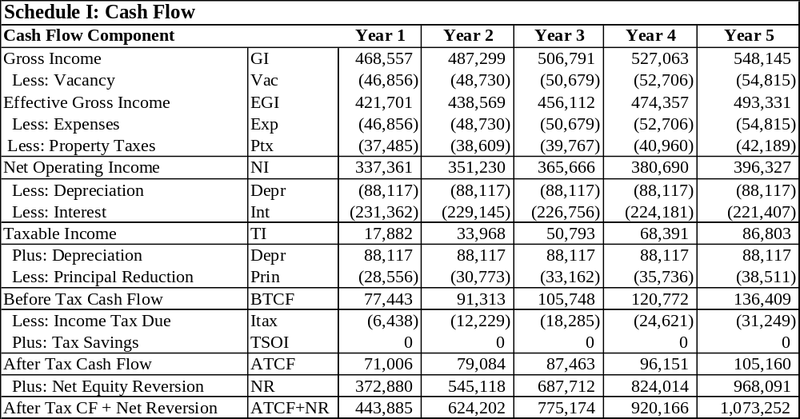

It should be noted that the items detailed in Schedule I present the minimal level of detail necessary to create a financial statement or proforma that generates After Tax Cash Flows and Net Reversions. In many cases, it would be desirable to present more detail to reflect multiple sources of revenue, more detailed expense categories, fixed and variable expenses and other items that would add to the precision of the analysis. There are two approaches that could be used to incorporate such considerations. The first approach would be to modify the Inputs and structure of Schedule I to include additional categories (see: Schedule I-B).

Exhibit 5: Multiple Sources of Revenue and Expenses

Cash Flow Component | Code | Year 1
Gross Income - Primary Use | GIp | 268,557
Gross Income - Secondary Use | GIs | 200,000
Gross Income | GI | 468,557
Less: Vacancy - Primary Use | Vp | (26,856)
Less: Vacancy - Secondary Use | Vs | (20,000)
Vacancy | Vac | (46,856)
Effective Gross Income | EGI | 421,701

The second approach to adding more precision to the base DCF with respect to income and expenses would be to create separate tables for more detailed income and expenses, and then merely plug the bottom line or aggregate values they generate into the base Schedule I. Such schedules could be created for rent roll analysis with different terms of leases, expense pass-throughs, renewal options and percentage leases (see: Schedule 1-C). As noted, the addition of such information will require more complex calculations, but could be important in analyzing an investment, especially if there are significant rent rolls that would introduce market risk to the equation. On a related note, the fact that some leases are fixed or subject to scheduled adjustments would render simple annual percent changes in rent invalid or, at a minimum, require adjustment to reflect the likely reality of income receipts. Similarly, operating expenses could be modeled at a more detailed level, as well as allowing differential treatment of fixed and variable expenses (i.e., those that are required and those that are a function of the occupancy levels of the property).

Exhibit 6: A Typical Rent Roll

Suite | Tenant | Lease Type | Size | Start Date | Term | Current $/SF/Yr
110 | Café Gotcha | Retail | 2,106 | 6/1/2003 | 5 | $20 + 10% over $50k sales
100 | First Bank | Retail/Office | 8,952 | 10/15/2002 | 7 | $25.00
200 | High Tech Company | Office | 5,349 | 8/21/2003 | 5 | $18.45
250 | Property Management | Office | 6,207 | 8/1/2003 | 5 | $10.00
270 | Conference Center | Office | 1,985 | 8/1/2003 | 5 | $20.35
290 | e-commerce R-Us | Office | 3,127 | 12/1/2006 | 3 | $13.00
300 | Capture Investment | Office | 12,670 | 2/24/2003 | 5 | $13.95

Before getting into the detailed DCF calculations, it is useful to step back and look at the key components that make up a cash flow statement and their relative importance to the bottom line. Exhibit 4 presents a stacked bar chart that shows relative cash flow claims as a percent of Gross Income (GI). As noted, the value of the respective components changes in each period, reflecting differential rates of growth. Despite constant payments, the market share of the mortgage payments changes as does the allocation between principal and interest as the loan is gradually amortized.

Exhibit 7: Graphical Representation of DCF 1`1`tems

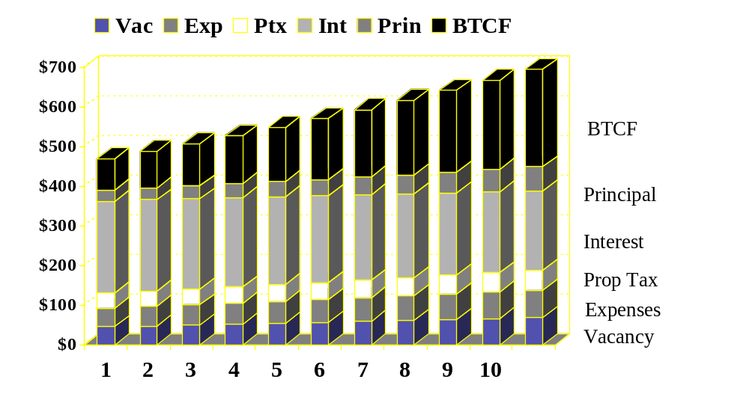

Year 1 Assumptions

The DCF begins with some form of Gross Income (GI) measure, usually related to the number of rental revenue units and the rental schedule. In some property types and situations, revenues might also be generated from other sources, including fees (e.g., health club, cleaning & janitorial, common area charges (CAMs), promotion, security) and miscellaneous revenues (e.g., utility charges, parking, restaurants, room service). In a typical DCF, the calculations focus on the first year inputs in a vertical sense, beginning with GI and moving toward NOI. Thus, Vacancy, Expenses and Property Taxes typically begin with a fixed dollar amount or a percent of gross income. These figures could come from detailed component analysis, or from rules of thumb. The tie-back to GI makes sense on a number of levels, including:

- It provides a market-based solution from industry sources (i.e., publications, comparable analysis or “rules of thumb),
- It ensures that the going-in pricing and analysis is compatible with the pricing assumptions (i.e., rules-of-thumb) the market would likely impose on the project that affect the “exit strategy”, and
- The normative values for the ratios are all implicitly tied to the gross income
  - Expenses should be commensurate with the income levels and qualitative positioning of the project to ensure appropriate maintenance,
  - Property Taxes should be based on an “ad valorem” basis; tied to value which is directly correlated with income levels.

Schedule I: GI to NOI

Once the first year levels of the respective variables are established (n = 1), the future years (n + 1) can be calculated. In most cases, the following year is derived by multiplying the then-current values by (1 + CHNG) where CHNG is the rate of change. In the case of Vacancy, the rate is usually fixed as a percent of Gross Income, although actual Vacancy Rate would be a function of market conditions, lease turnover, tenant retention, and tenant credit.

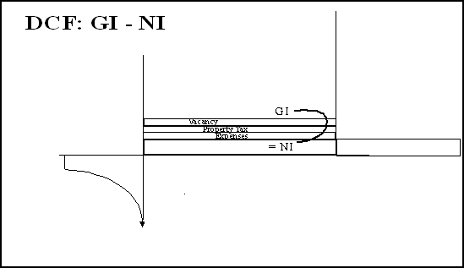
Exhibit 8: GI – NOI Graphical View

Exhibit 9: Gross Income to Net Operating Income (NOI) Flow
Cash Flow Component
Year 1
Initial Calculation
Year 2
Gross Income
468,557
= GIn
GIn-1 * (1+ RC)
487,299
Less: Vacancy
(46,856)
= -(GIn * Vr)
(48,730)
Effective Gross Income
421,701
438,569
Less: Expenses
(46,856)
= (-GIn * Er)
Expn *(1+ExpC)
(48,730)
Less: Property Taxes
(37,485)
= (-GIn * PTXr)
PTxn*(1+PTxC)
(38,609)
Net Operating Income
337,361
351,230

In this case, the calculations from GI to NOI follow a distinct pattern, although the actual levels would depend on the structure of leases, rates of inflation and other factors that could affect the rate of change over time. In general:

Gross Income

  - Initial Gross Income is typically derived by multiplying the revenue per unit by the number of units for each rental category.
  - Going forward, GI changes by an assumed rate of Rent Change (RC) or by some multi-period rental schedule that would reflect lease terms or other scheduled changes.

Vacancy

  - The initial vacancy rate is calculated by establishing a reasonable allowance for vacant space in the initial occupancy period.
  - It should be noted that Vacancy is an allowance rather than an actual expense or other cost of occupancy or operations. As such, if a project operates at a lower vacancy rate, the excess benefits flow directly to the NOI line, creating upward pressure on rate of return.
  - After the initial period, the vacancy allowance is typically expressed as a percent of Gross Income and is often run at a flat percentage, fluctuating with market rents and lease negotiations

Expenses

  - The Expense line represents the aggregate value of various operating expenses, both fixed and variable.
    - Fixed Expenses are incurred regardless of occupancy levels and are necessary to maintain the integrity of the basic structure.
    - Variable Expenses are expenses that are a function of occupancy levels, relating to marginal items that vary with the intensity of use.
  - In addition to varying by property type and sub-type, operating expenses depend on the “efficiency” of the underlying facility and systems, as well as the level of service dictated by the nature of tenancy and the support level necessary to maintain the premises to satisfy tenant demand.
  - After the initial Expenses are established, future levels are calculated by multiplying current year charges by (1 + ExpC), where ExpC is the change in expenses. This may be related to inflation or to local market experience.
  - In many projects, it is prudent to establish a Reserve for Replacements; a set-aside allocation of operating income that is escrowed to cover non-recurring expenses for short-lived mechanicals and systems. This allows the project to cash-flow, without the risk of unexpected “shocks” to the NOI that are likely to occur.
Property Taxes

  - In most U.S. jurisdictions, Property Taxes operate on an “ad valorem” base, legitimized by the exercise of “police power.” As such, they are directly related to market value of the asset which may be determined by:
    - Cost or appraised/assessed market value, or
    - Income ratios, which are set as a percent of gross income and, after discounting or capping at market yields, should approximate market value.
  - In addition to Property Taxes, jurisdictions might invoke a variety of related fees and/or adjustments that will affect the Property Tax line including:
    - Payments in Lieu of Taxes, a partial payment that is levied to encourage or reward certain use behavior.
    - Tax Increment Financing (TIF), which is a form of leveraged financing in which a jurisdiction funds improvement that is targeted to the benefit of particular projects.
    - Special Tax Districts (STDs) which are used to spread the cost of infrastructure or related items over a targeted geographic area.
    - Special Assessments, which are non-recurring fees attributable to certain improvements or services.
  - Property tax changes can be pegged to the current level by multiplying the current year property taxes by (1 + PTxC); it should be noted that, if market conditions result in a decline in value, taxes can be appealed to make sure they are in line with market values and maintain their “ad valorem” anchor.

Schedule I: NOI to Before Tax Cash Flow

Once the NOI has been calculated, the DCF schedule flows through to Before Tax Cash Flow (BTCF). While the GI to NOI calculation was fairly linear, the NOI-BTCF requires the creation of two separate schedules: Depreciation, and Loan Amortization.

Exhibit 10: NOI to Before Tax Cash Flow (BTCF) Flow

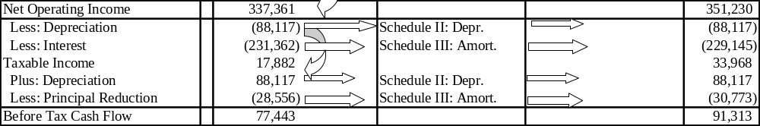

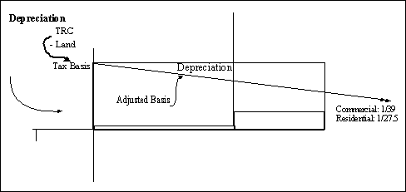

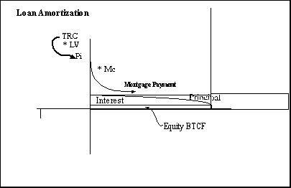

Supporting Schedules II-V

Schedule II: Depreciation

In the current tax environment, the calculation of Depreciation is relatively straightforward, with two depreciation schedules:

- Commercial Real Estate. The broad class of commercial real estate refers to all non-residential properties (e.g., retail, office, industrial, and hotel) and follows a straight-line model with a 39 year useful life (i.e., 1/39% of the Depreciable Basis) that can be written off each year.
- Residential Real Estate. The term refers to multifamily or single family rental property that follows a 27.5 useful life, translating to 1/27.5% per year.
- Component Depreciation. In some cases, separate depreciation schedules can be followed for other property components which can be extracted from the current tax code.

Exhibit 11: Depreciation Graph

As noted in Schedule II, the calculation of depreciation is restricted to the physical improvements that are subject to deterioration; land is not a depreciable asset. The depreciation schedule begins with current year Tax basis, and then:

- Deducts Depreciation, at the straight line rate, and
- Adds in Capital Improvements that:
  - Enhance the asset base, and
  - Are not related to basic maintenance and operations.
- The End-of-Year Tax Basis becomes the Beginning of Year (n + 1) basis and the cycle is repeated.

Schedule II: Depreciation

Schedule II: Depreciation
Year 1
Year 2
Year 3
Year 4
Year 5
Total Replacement Cost
3,872,167
Less: Land
(435,600)
Beginning of Year Tax Basis
3,436,567
3,348,450
3,260,333
3,172,216
3,084,099
Less: Depreciation
(88,117)
(88,117)
(88,117)
(88,117)
(88,117)
Plus: Capital Improvements
End of Year Tax Basis
3,348,450
3,260,333
3,172,216
3,084,099
2,995,981
Plus Land
435,600
435,600
435,600
435,600
435,600
Adjusted Basis
3,784,050
3,695,933
3,607,816
3,519,699
3,431,581
Accumulated Depreciation
88,117
176,234
264,351
352,468
440,586

Exhibit 12: Depreciation Flow

Schedule II: Depreciation
Component
Year 1
Year 2
Total Replacement Cost
3,872,167
Less: Land
(435,600)
Beginning of Year Tax Basis
3,436,567
3,348,450
Less: Depreciation
(88,117)
(88,117)
Plus: Capital Improvements
End of Year Tax Basis
3,348,450
3,260,333
Plus Land
435,600
435,600
Adjusted Basis
3,784,050
3,695,933
Accumulated Depreciation
88,117
176,234

Schedule III: Loan Amortization

The Loan Amortization Schedule III follows a different logical flow than other schedules due to the necessity to allocate total payments between Principle and Interest. This allocation is referred to as amortization, which refers to the fact that in most mortgage arrangements, the lender establishes a repayment schedule that pays off the principle over time, shifting the fixed payment between principle reduction and interest. During the early years of a loan, the vast majority of payments are allocated to Interest. Over time, the Principle allocation accelerates in a geometric pattern that reduces the outstanding balance to zero at the end of the amortization period. The splitting of Principle and Interest charges is necessary for tax purposes since the IRS allows a deduction for Interest which is a charge for using capital, but disallows it for Principle Reduction through which a buyer “buys-back” the debt piece, increasing their share of net proceeds upon sale.

Exhibit 13: Graphical Representation of Loan Amortization

Schedule III: Loan Amortization

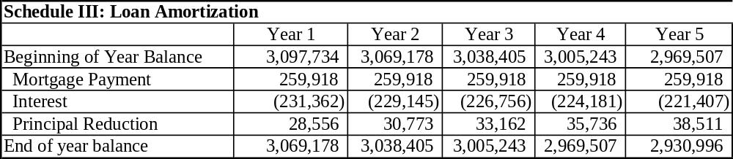

Schedule III presents the flow of funds in an amortizing loan. Since mortgage payments are made monthly, and DCF is usually presented annually, an indirect approach becomes the easiest way to isolate the Principle and Interest portions.

- First, to establish the total annual Mortgage Payment, plug in the periodicity (i.e., monthly or annual), the interest rate and term to arrive at a Mortgage Coefficient (Mc) to amortize $1. Then, multiply the Mc by the amount of the Mortgage (TRC * Loan-to-Value), to establish the monthly. This figure is multiplied by 12 to get the total annual payment.
- Second, calculate the Principle Balance outstanding at the end of the year as noted in Exhibit V (b) by plugging the “unfulfilled promise” or remaining Term into the calculator and solving for PV.
- Finally, back into the Interest and Principle allocation by subtracting the change in Principle from the total payments; the balance is the Interest, and plugging the figures back into the schedule.

Exhibit 14: Loan Amortization Flow
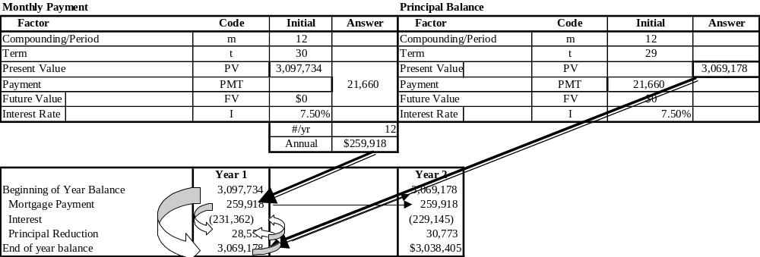

Schedule IV: Capital Gain Tax on Sale

The Capital Gain Tax on Sale is a rather straightforward calculation, with a fixed rate (e.g., 20%) applied to the Capital Gain; the difference between Sales Price and the Adjusted Basis. As in the case of income taxes, an investor can also capture Capital Gain Tax Savings in the case of paper losses, although the extent to which they can be deducted in the current period is subject to additional regulation.

Schedule IV: Capital Gain Tax on Sale

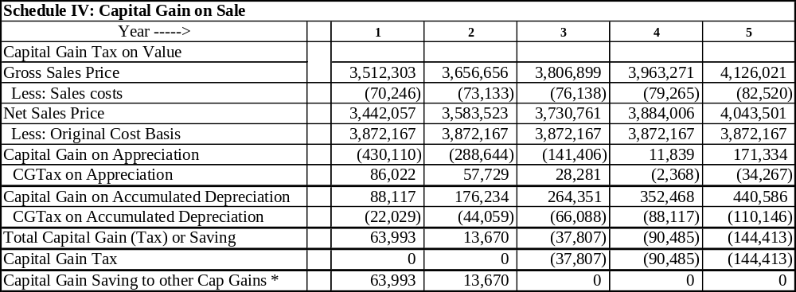

Schedule V: Net Reversion; After Tax, After Sale Proceeds

The final element of the DCF schedule is to isolate the Net Reversion to arrive at a vector of the total benefits that accrue to equity. As noted earlier, the DCF model presented herein is set up to evaluate returns with and without sale in each of the forecast years. In reality, the investment can only be sold in one of the years, with the exception of partial sales which may occur where multiple buildings are involved or where the ownerships structure is a condominium. To provide flexibility and insights into the impact of sales prior to the end of the 10th year, the Net Reversion is calculated for each year. The calculation of Income Tax or Tax Savings is dichotomous: if Taxable Income is positive, Income Taxes are due which are equal to TI * Marginal Tax Rate; if TI is negative, Tax Savings are equal to –TI * MTR.
Exhibit 15: BTCF to After Tax Cash Flow + Net Reversion
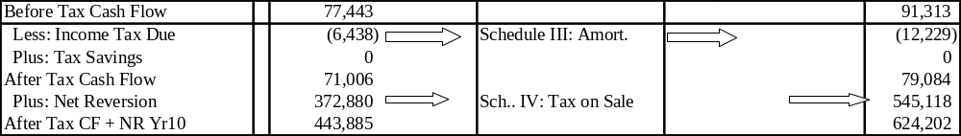

To calculate the Net Reversion, two separate schedules must be completed: Schedule IV: Capital Gain Tax on Sale; and, Schedule V: After Tax, After Sale Proceeds. In discussing the Capital Gain Tax, it should be noted that the Depreciation Allowance that is included in the annual cash flow calculations to arrive at Taxable Income is not a forgiveness of taxes, but a deferral until the asset is sold. This provides a “Time Value of Money” benefit, deferring taxes to a future date. In addition, the Capital Gains Tax Rate at 20% is lower than the periodic marginal tax rate, providing an added benefit to investors. The Capital Gain calculations involve several steps:

- First, the Gross Sales Price is calculated. This figure can be derived through several approaches as illustrated in Exhibit 16. That is, the Gross Sales Prices can be derived by:

  - The initial TRCm can be inflated by a compound rate of appreciation (2% in the example), or
  - The Net Operating Income in the following year (NOIn+1) or the stabilized NOI can be capitalized by the Exit Cap Rate.

- Second, Sales Expenses which vary by transaction size, local market customs and negations are deducted from the sales price.
- Third, the outstanding Principle Balance (Pb) is netted out, with the figures extracted from the Amortization Schedule.
- Fourth, the Cap Gains Tax or Cap Gains Loss (Schedule V) is netted out to arrive at an After Tax Sale Proceeds
  - The portion of the “gain” due to appreciation is taxed at 20%
  - The portion of the “gain” which represents recapture of Depreciation is taxed at 25%. Thus, Depreciation is not actually a “forgiveness” of federal taxes, but merely a deferral that benefits from the time-value-of-money, as well as a reduction the rate of taxation from the marginal income tax rate.

Exhibit 16: Net Reversion Graph

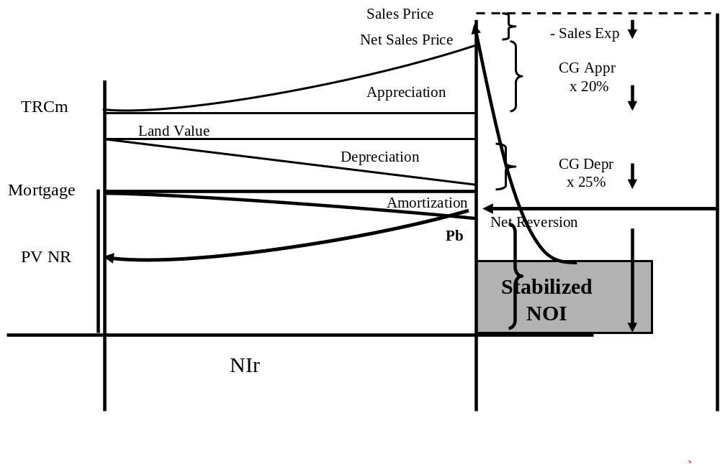

Schedule IV: After Tax, After Sale Proceeds

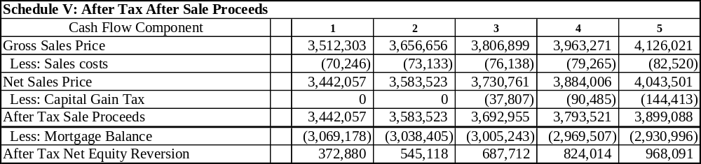

At this point, the respective values from each of the schedules can be plugged back into Schedule I to indicate the bottom line of benefits: After Tax Cash Flow plus Net Reversion.

Schedule VI: Financial Ratios

Once the Schedule II-V calculations are completed, the DCF analysis can turn to Financial Ratios that can be used to determine whether an investment is an attractive acquisition, or to determine optimal holding period. Schedule VI (a) presents some of the key financial ratios for the sample DCF, while VI (b) presents the equations. Since each ratio approaches a different project indicator, it is useful to review each of them individually.

Schedule VI (a): Financial Ratio Pro Forma

Schedule VI: Ratio Analysis
Code
Year 1
Year 2
Year 3
Year 4
Year 5
Debt Coverage Ratio
DCR
1.30
1.35
1.41
1.46
1.52
Default Ratio
DR
0.73
0.71
0.69
0.67
0.65
Profitability Index
PI
0.52
0.75
0.92
1.06
1.20
Before Tax Cash on Cash
BTCF
10.00%
11.79%
13.65%
15.59%
17.61%
After Tax Cash on Cash
ATCF
9.17%
10.21%
11.29%
12.42%
13.58%
Implicit Cap Rate
ICr
10.00%
10.00%
10.00%
10.00%
10.00%
Gross Income Multiplier
GIM
7.50
7.50
7.51
7.52
7.53
Net Income Multiplier (P/E)
NIM
10.41
10.41
10.41
10.41
10.41
Payback Ratio (w/o sale)
PB
9.17%
19.38%
30.67%
43.09%
56.67%
Modified Payback (w/o sale)
MPB
9.17%
19.93%
32.42%
46.78%
63.17%
NPV Equity (sold/year)
NPV
($370,901)
($194,013)
($62,124)
$49,674
$153,266
IRR if Sold/Year
IRR
-42.68%
-5.52%
6.69%
11.96%
14.76%
Modified IRR if Sold/Year
MIRR
-42.68%
-4.96%
6.63%
11.25%
13.48%
Marginal Rate of Return
MRR
40.62%
24.19%
18.70%
16.64%

Schedule VI (b): Financial Ratio Equations

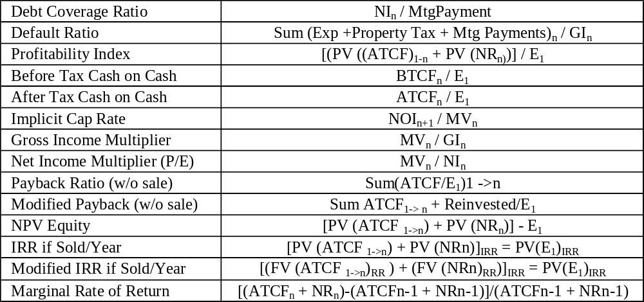

Debt Coverage Ratio (DCR)

  - Definition: NOI_{n}/MTG$_{n}
  - Interpretation:
    - DCR provides a measure of the safety of the mortgage position, providing an indication of the cushion between required payments and NOI.
    - When NOI is expected to increase over time, use year 1 NOI.
    - DCR’s should normally be at least 1.2, providing a downside cushion

Exhibit 17: Debt Coverage Ratio

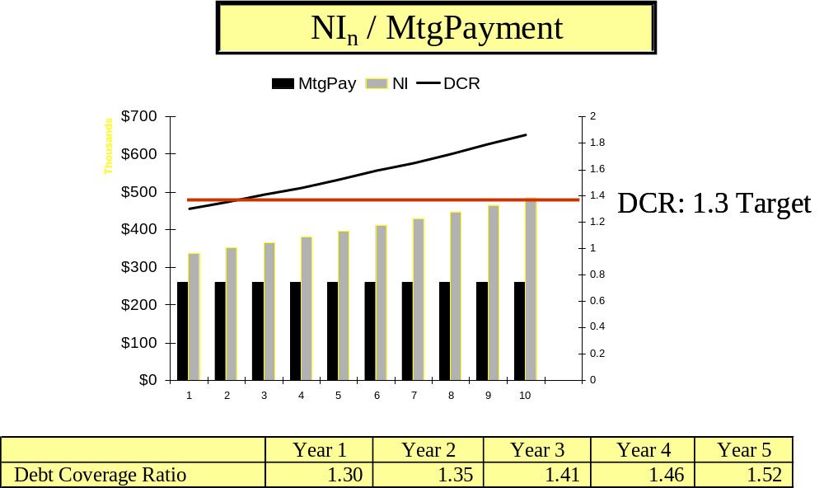

Default Ratio

  - Definition: (Exp_{n} + PTX_{n} + MTG$_{n}) / GI_{n}
  - Interpretation:
    - DR gives a measure of the risk associated with a real estate investment
    - In essence it is the ratio of fixed costs to Gross Income
    - The complement of the Default Ratio indicates the maximum cumulative variation between expectations and realizations before a project will not cash flow; it could be higher expenses or Vacancy Allowance, the only CF variable not considered in the calculation.
    - In general, looking for a ratio around or less than .85 for a typical project.

Exhibit 18: Default Ratio

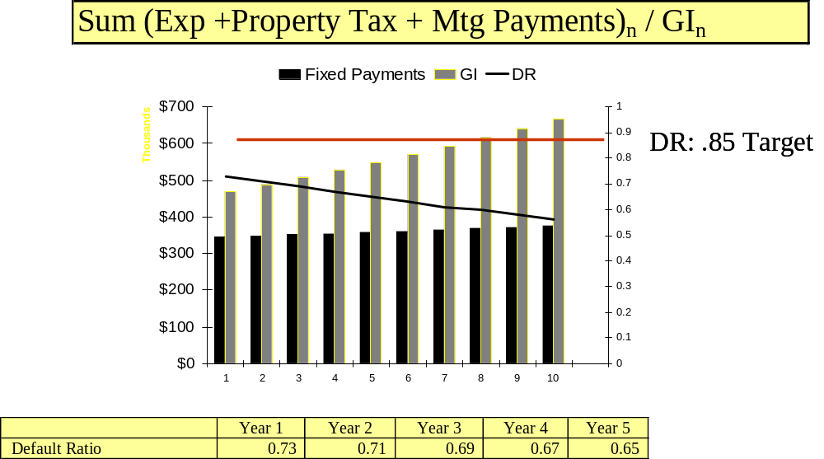

Profitability Index (PI)

  - Definition: [PV (CF_{1-n}) - PV (NR_{n})] / EQ₁
    - Where EQ₁ is initial Equity Investment
    - PV (CF_{1-n}) is the present value of the aggregate cash flows to that period
  - Interpretation
    - Related to NPV calculation; if PI is over 1, NPV is positive
    - In this case, increasing PI indicates project is improving with longer hold

Exhibit 19: Profitability Index

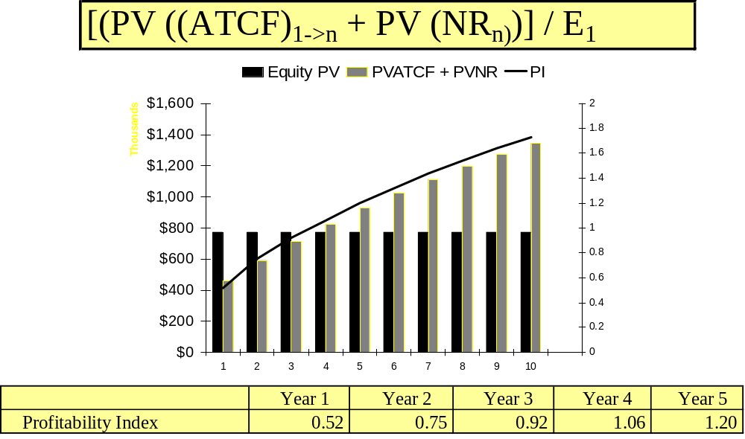

Before Tax Cash on Cash (CoC) Return

  - Definition: BTCF_{n}/ EQ₁
    - Where EQ₁ is initial Equity Investment
    - BTCF is the Before Tax Cash Flow in the respective year
  - Interpretation
    - Indicates pretax distributable cash relative to initial investment
    - In this case, shows a modest cash flow regardless of tax implications; modest improvement suggest cash basis improves over time.

Exhibit 20: Before Tax Cash on Cash (CoC) Return
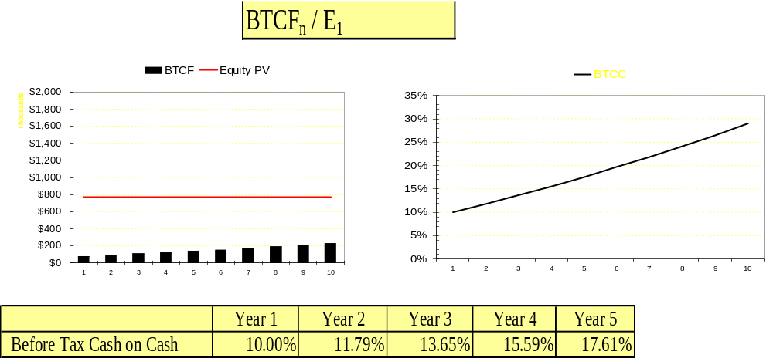

After Tax Cash on Cash (CoC) Return

  - Definition: ATCF_{n}/ EQ₁
    - Where EQ₁ is initial Equity Investment
    - ATCF is the After Tax Cash Flow in the respective year
  - Interpretation
    - Indicates pretax distributable cash relative to initial investment
    - In this case, shows a modest cash flow regardless of tax implications; modest improvement suggest cash basis improves over time.

Exhibit 21: After Tax Cash on Cash (CoC) Return

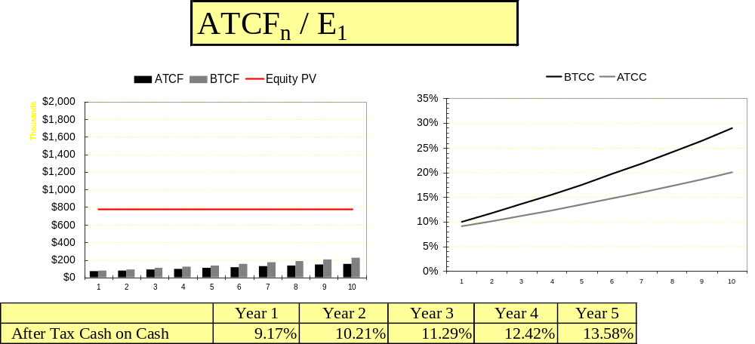

Implicit Cap Rate

  - Definition: NOI_{n+1}/MV_{n}
    - where NOI_{n+1} is the next year’s NOI
    - MV_{n} is the current year’s gross sales price assuming an end of year sale
  - Interpretation
    - Measure corresponds with “cap rate” rule of thumb
    - Provides indication of relative pricing level

Exhibit 22: Implicit Cap Rate

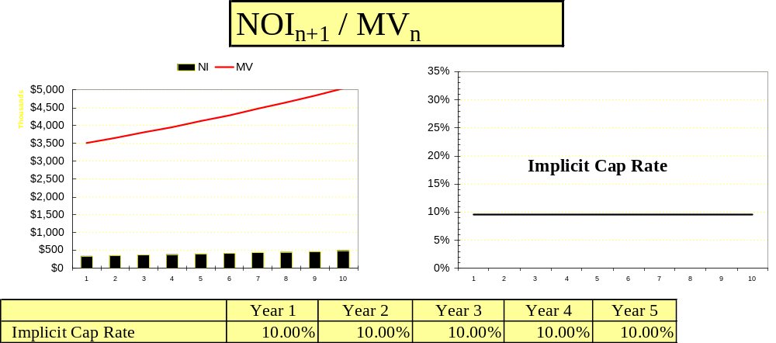

Gross Income Multiplier (GIM)

  - Definition: MV_{n}/GI_{n}
  - Interpretation:
    - an industry figure that provides a market barometer
    - the GIM determines how the gross income relates to market value of the underlying asset

Exhibit 23: Gross Income Multiplier

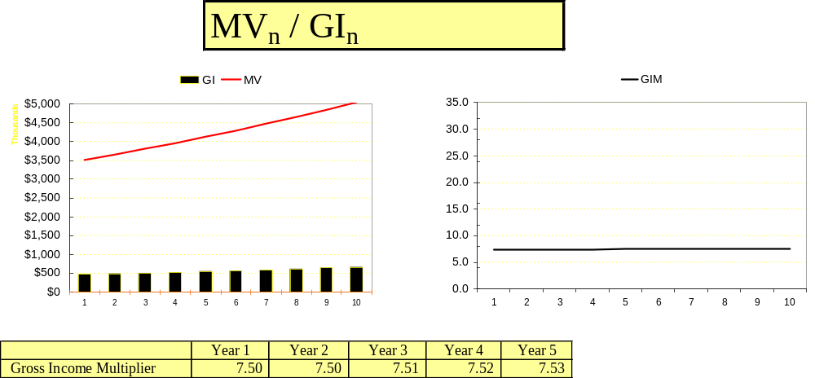

Net Income Multiplier (NIM)

  - Definition: MV_{n}/NI_{n}
  - Interpretation:
    - an industry rule of thumb sometimes used to relate income to value
    - analogous to the P/E ratio in finance

Exhibit 24: Net Income Multiplier

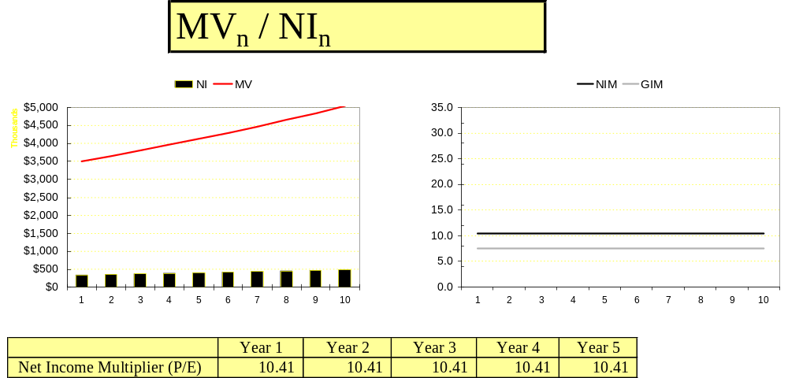

Payback Ratio (w/o sale)

  - Definition: Sum (ATCF_{n-t})/ (EQ₁)
    - Provides a measure of the return “of” the equity investment
    - Ignores reinvestment assumption; works with simple aggregate ATCF
    - Ignores sale of asset; focuses on cumulative ATCF
  - Interpretation:
    - Provides a measure of the timing of the cash flows
    - Timing & magnitude used to compare risk vs. other investments

Exhibit 25: Payback Ratio

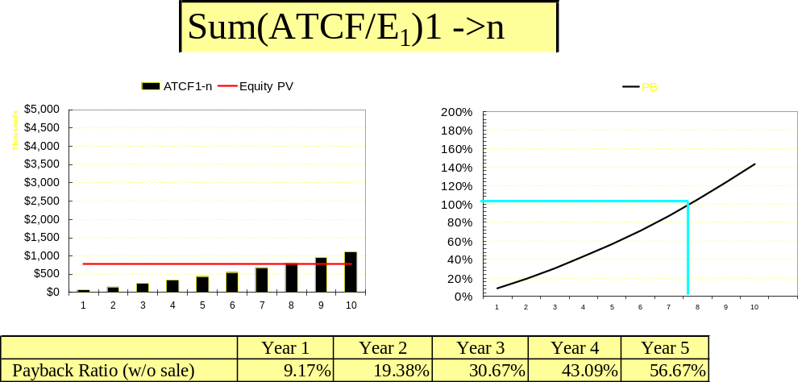

Modified Payback Ratio (w/o sale)

  - Definition: SUM (ATCFn *(1 + rr)^{(t-n)} / (EQ₁)
    - Similar to Payback Ratio but recognizes reinvestment of proceeds
    - Provides measure on the return “of” investment
  - Interpretation:
    - Helps evaluate timing of return
    - Indicates some of the temporal risk exposures

Exhibit 26: Modified Payback Ratio

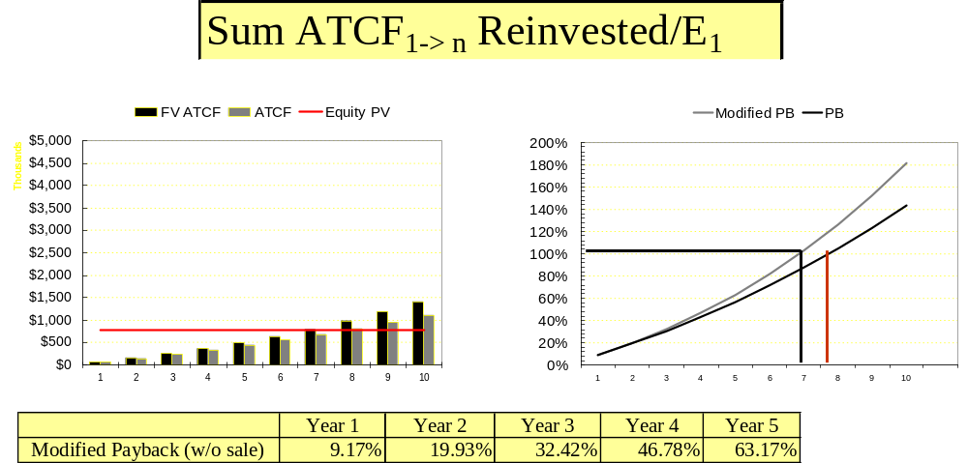

Net Present Value

  - Definition: [PV (ATCF_{1->n}) + PV(NR_{n})] - EQ₁
  - Interpretation:
    - A traditional finance measure that compares the PV of outlays to the PV of benefits at the assumed discount rate.
    - If NPV is positive, then the benefits outweigh the costs at the assumed discount or yield rate.

Exhibit 27: Net Present Value

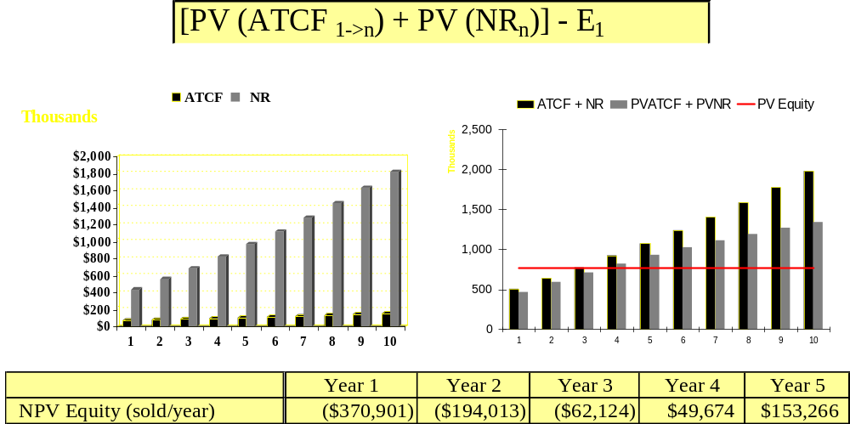

Marginal Rate of Return

- Definition: [(ATCF_{n} + NR_{n})-(ATCF_{n-1} + NR_{n-1})]/(ATCF_{n-1} + NR_{n-1})
  - Interpretation:
    - The rate of return that is realized by holding on to the investment one more period.
    - Compares net terminal value in current year vs. prior year to see if investment performance is decelerating or accelerating

Exhibit 28: Marginal Rate of Return

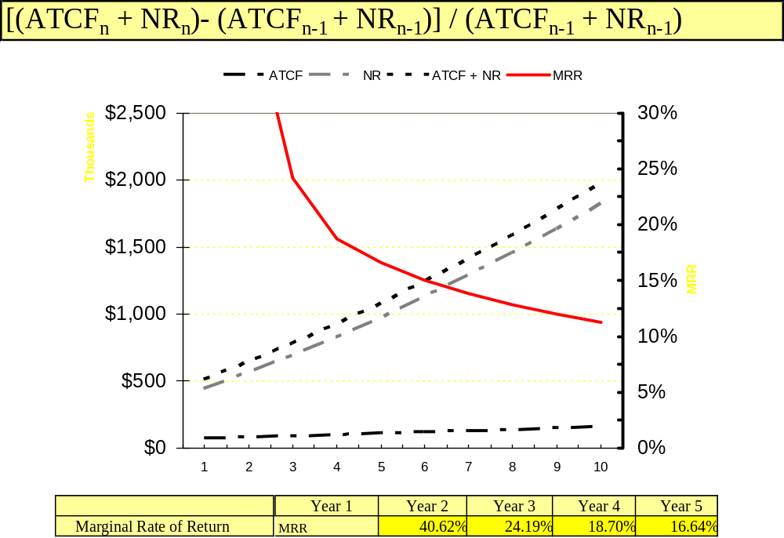

Schedule VII: IRR & MIRR

Overview of IRR

The Internal Rate of Return (IRR) is one of the key financial ratios used in analyzing the economic viability or feasibility of real estate investments. The IRR builds on the Net Present Value (NPV) framework of finance, solving for the rate of return or discount rate at which the PV of outlays or investments equals the PV of the benefits. In this case, the outlays consist of the initial equity investment, along with additional capital expenditures or advances that might be made during the life of the investment. The “benefits” consist of the After Tax Cash Flow thrown off each year along with the Net Reversion. In effect, the IRR calculations employ an iterative approach in which the rate that sets the PV of Outlays is equal to the PV of Benefits. Depending on the timing and magnitude of Outlays and Benefits, the IRR might result in multiple solutions or might not converge on an answer. It should be noted that the IRR implicitly assumes that all proceeds –periodic After Tax Cash Flows—are invested at the IRR.

Exhibit 29: IRR Graphical Representation

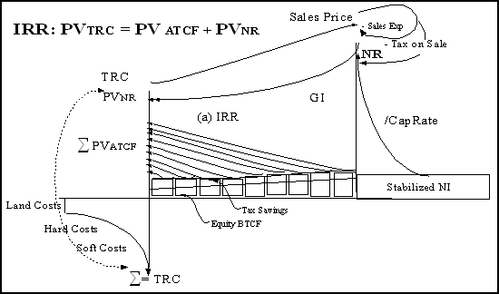

Schedule VII-A: Internal Rate of Return (IRR)

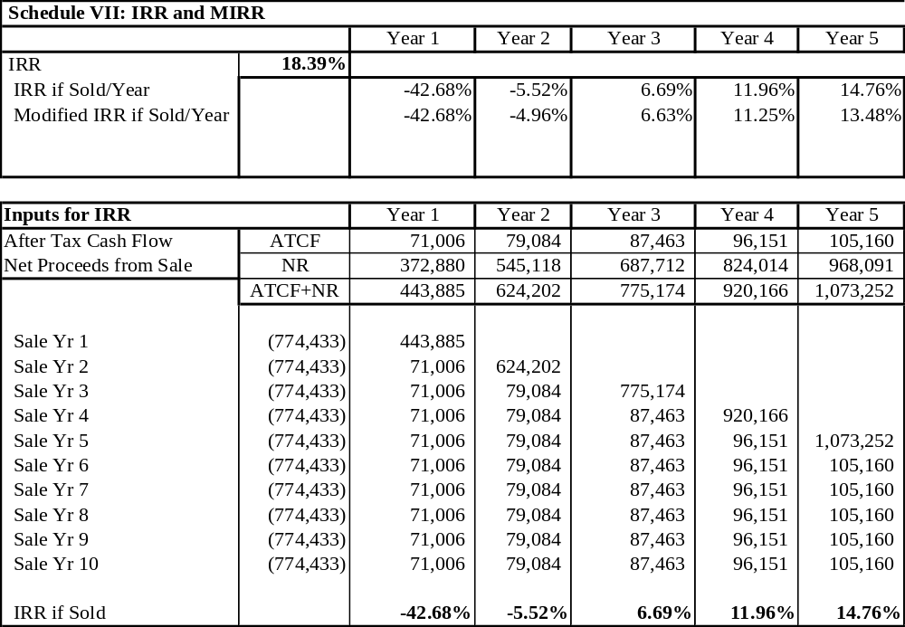

Overview of MIRR

The Modified Internal Rate of Return (MIRR) follows a similar logic to the IRR calculation, with one major exception. That is, the MIRR recognizes that an investor might not be able to tap into the same level of returns with marginal cash flows as with total investment outlays. This is particularly true in the real estate arena where the somewhat limited cash flows each period would not be sufficient to acquire or access a similarly yielding asset. Thus, the MIRR allows the investor to specify a more realistic –and generally lower—reinvestment rate for smaller, shorter term investments. The calculation takes the periodic ATCF and Tax benefits and compounds them forward to the terminal value, which is then added to the Net Reversion. Once this aggregate Future Value is established, the MIRR becomes the rate of return that balances the PV of Outlays with the PV of benefits.

Exhibit 30 : MIRR Graphical Representation
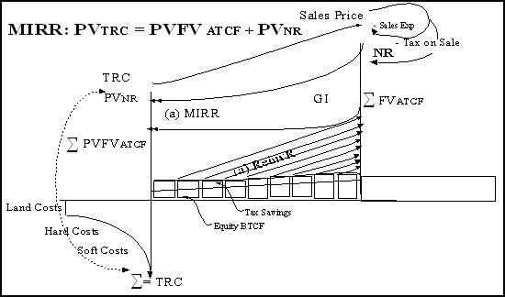

Schedule VII-B: Modified Internal Rate of Return

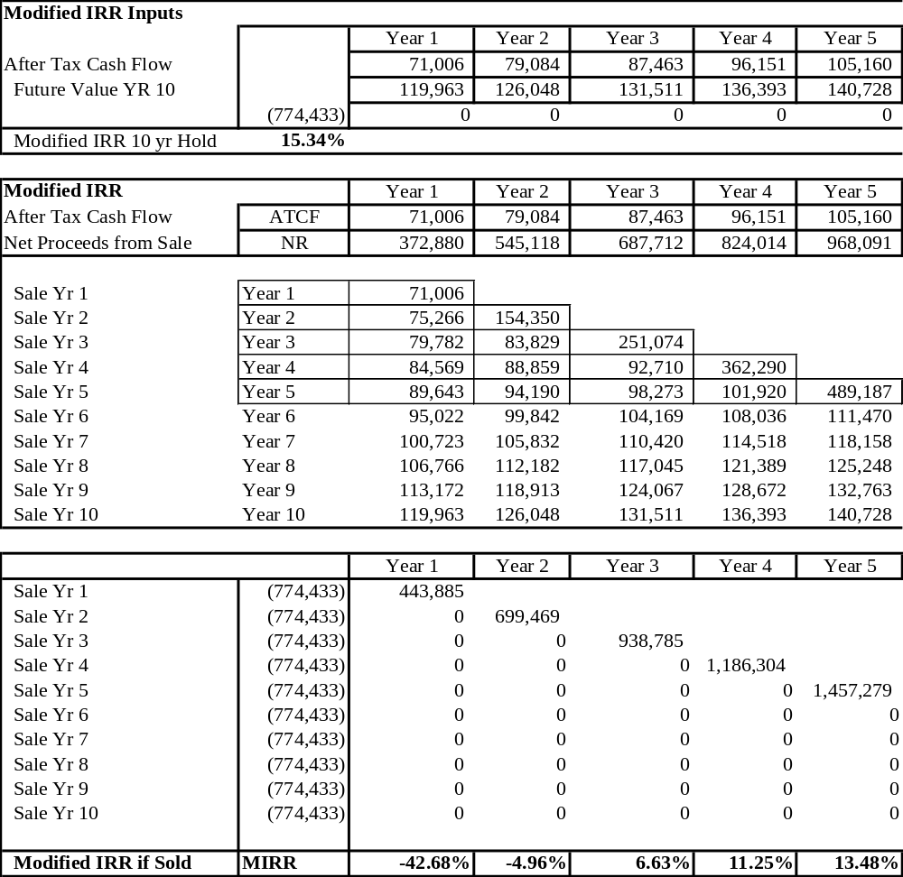

DCF Conclusion
As noted in this handout, a Discounted Cash Flow model has a relatively straightforward base that leads to an infinite variety of modifications and refinements. While these “bells and whistles” can help with the precision in the analysis of a real estate opportunity, a basic DCF is adequate to support many real estate investment decisions. Building on the foundation, a variety of adjustments can be made to customize a DCF to a particular real estate investment decision.

